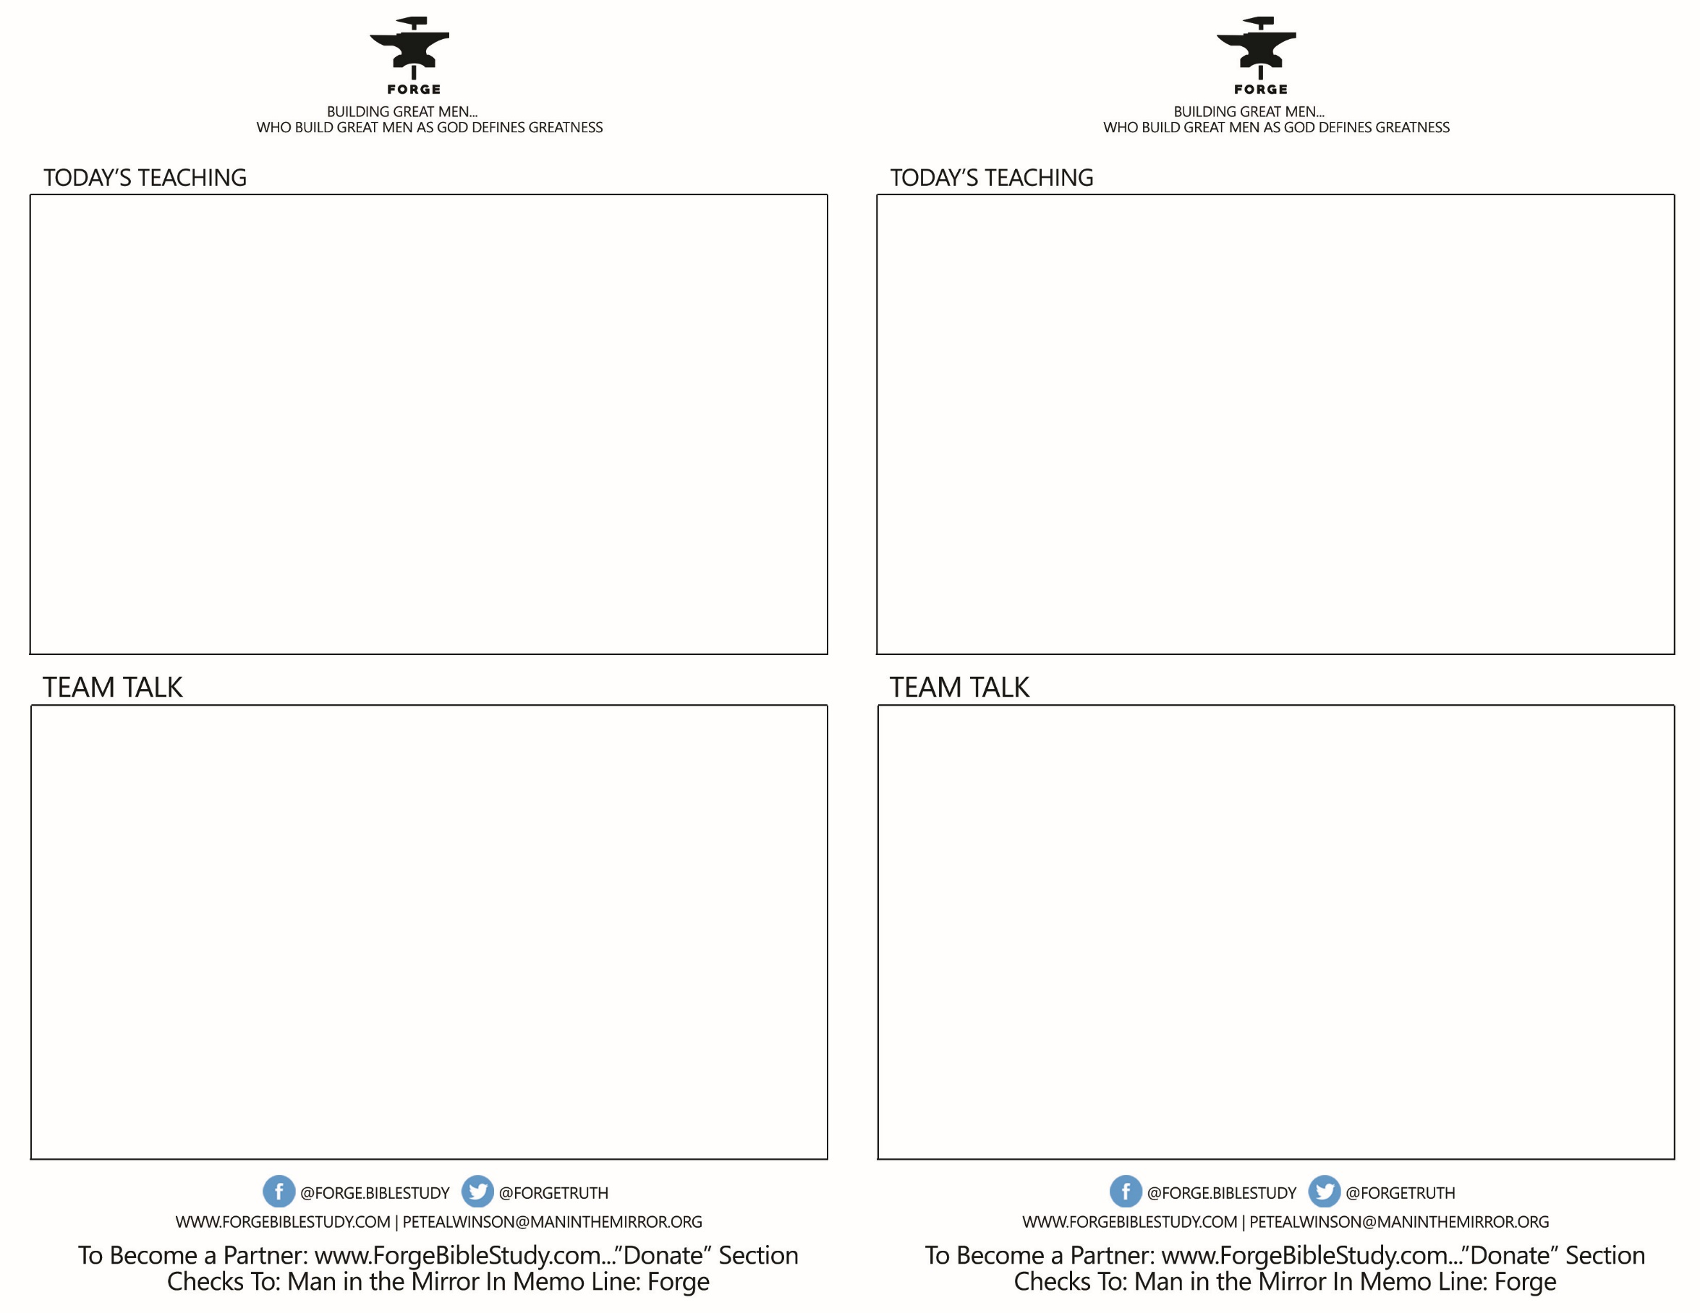

* What one or two life changes did you make in 2018 that were positive for you and your family?
* What is the one take away FOR YOU today concerning next year?
* Of the 5 challenges for FORGE for 2019, which one particularly energizes you?
* What one or two life changes did you make in 2018 that were positive for you and your family?
* What is the one take away FOR YOU today concerning next year?
* Of the 5 challenges for FORGE for 2019, which one particularly energizes you?

**YOUR CALL! Answering Man Questions**

***“What Do I Do With My Life?” Thoughts for 2019***

**YOUR CALL! Answering Man Questions**

***“What Do I Do With My Life?” Thoughts for 2019***