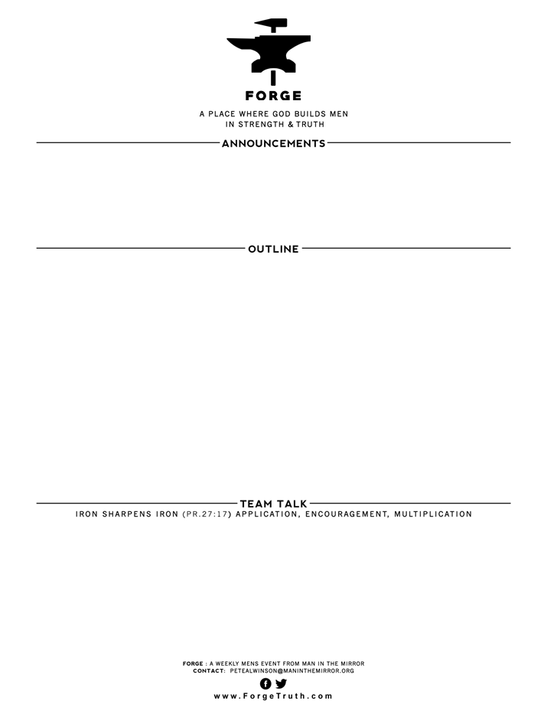

1. This message is more intellectually based than some others at FORGE, but what did you learn about 2 Timothy 3:14-17 that helped you become more confident as a Christian man?
2. What about the above 3 points helped your confidence in the Bible to grow, if anything?
3. What is the main “take away” for you today?

**APRIL 1 5-7 PM- THE GATHERING IN OVIEDO**

**CITIZEN’S BANK Leader: Rick Kingsland**

**THE BOOKS OF THE BIBLE:** Exegesis of 2 Timothy 3:14-17

1. HOW DID THE BOOKS IN THE BIBLE GET THERE? (ie, How did they determine what was Scripture)
2. WHY WERE OTHER BOOKS LEFT OUT OF THE BIBLE?
3. HOW DID THE BIBLE GET PASSED DOWN TO US TODAY?