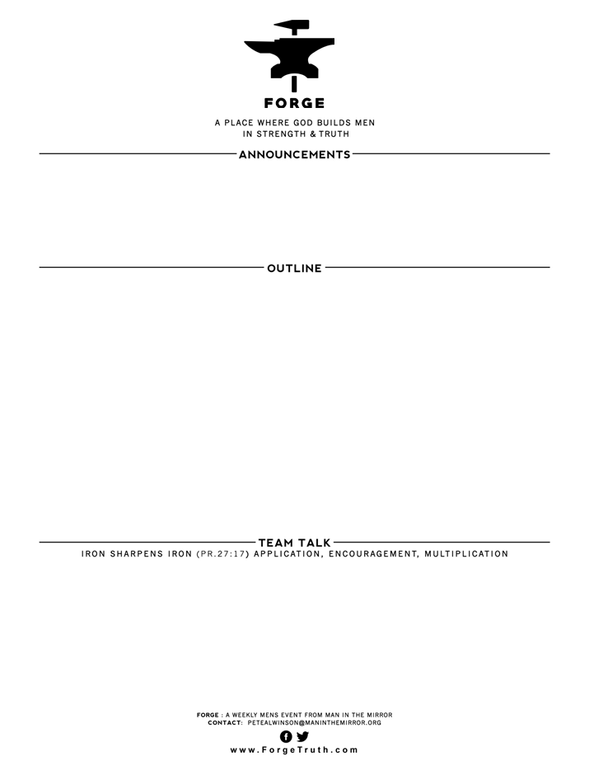

1. Review: What does the word ‘apostle’ (2 Peter 1:1) mean and what weight of authority does an apostle carry with him when he speaks? Why is this important when it comes to the New Testament? 2. Discuss around the table to cement in our minds: Why do we know that the Old Testament is the Word of God?

3.Discuss what was said about the nature of truth and what most Americans (& Westerners) believe about truth today (ie, Truth is Relative). Do we Christians get caught up in this view? How can we stay away from this influence?

**MARCH 11 BETTER MAN EVENT**

**APRIL 1 OVIEDO GATHERING**

**NEW SERIES: TRUTH-THE FOUNDATION OF MANLY CONFIDENCE**

**THE BIBLE AS THE FOUNDATION OF TRUTH**

**2 Peter 1:1,16-2:3**

1. **THE ULTIMATE AUTHOR OF THE BIBLE: v1,20-21**
2. **THE RELIABILITY OF THE HUMAN AUTHORS OF THE BIBLE: v16-19**
3. **THE LOGICAL RESPONSE TO THE BIBLE BY CHRISTIANS: v19**
4. **THE INEVITABLE & UNENDING WAR AGAINST THE TRUTH: 2:1-3**