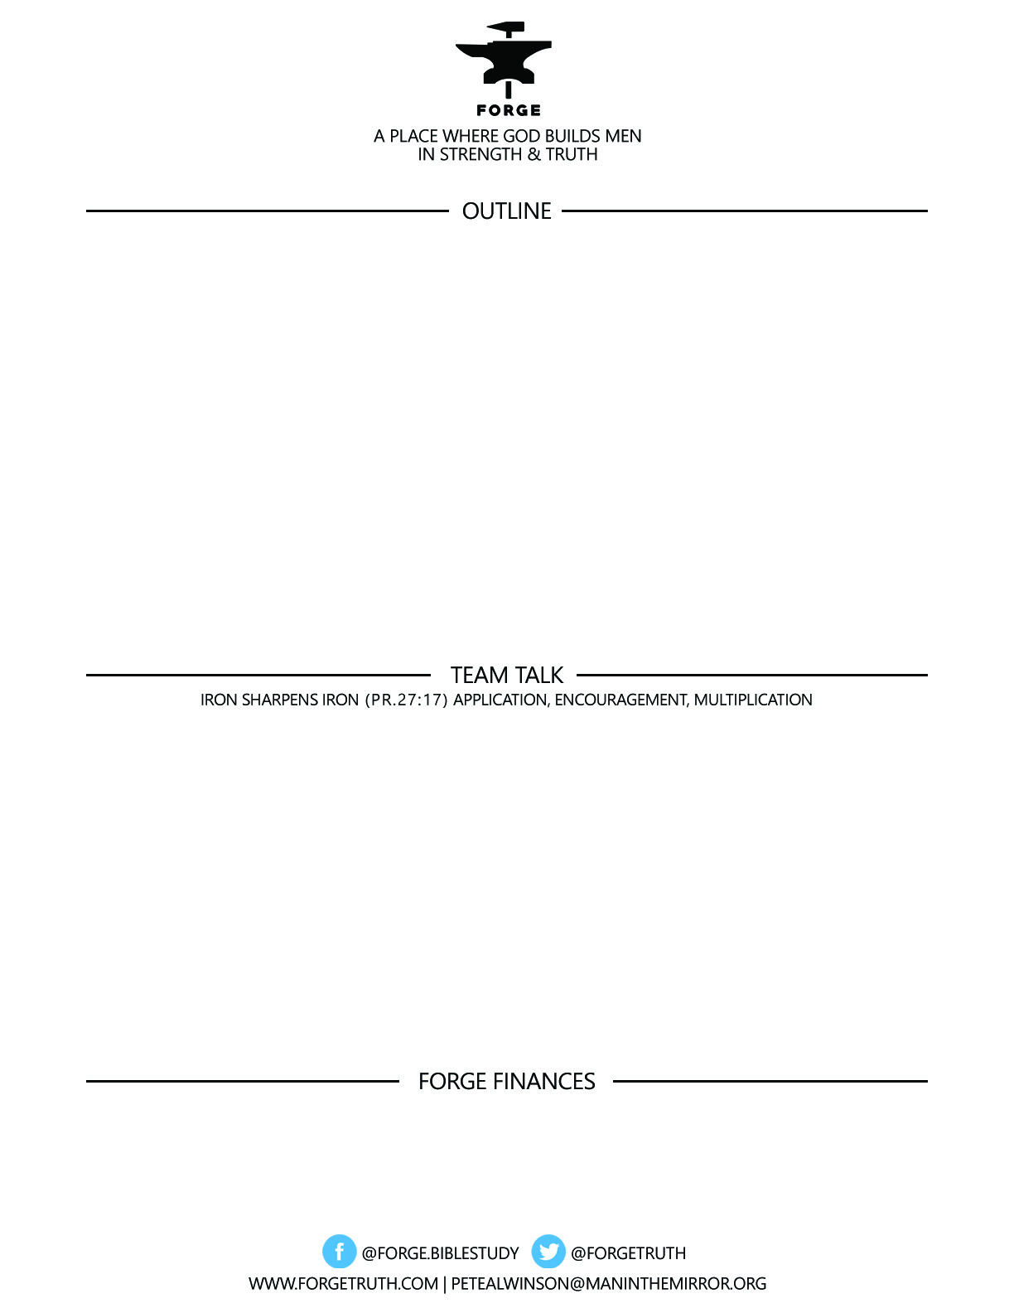

**TITANS FOR TODAY- The NT Book of Titus: TITANS IN THE CHURCH 3:8-15 #4**

**The Leadership Men Can Give Their local Churches: Exhort their churches to…**

1. **CONNECT GOD’S GRACE TO GOOD DEEDS**
2. **SHUN FOOLISH CONTROVERSIES**
3. **REJECT FACTITIOUS PEOPLE**
4. **SUPPORT MISSION EXPANSION**

***To become a partner:*** [***www.ForgeTruth.com....”donate***](http://www.ForgeTruth.com....)***” section.***

***Checks To: Man in the Mirror In Memo Line: FORGE***

1. Quickly review the types of “Churches” that exist in order to cement this concept in your mind.
2. What would constitute “foolish controversies” in the church today? What are some legitimate controversies?
3. Read through Matthew 18:15-20 & review the process for dealing with a ‘factitious person” in the church. Are you a factitious or a uniting man?