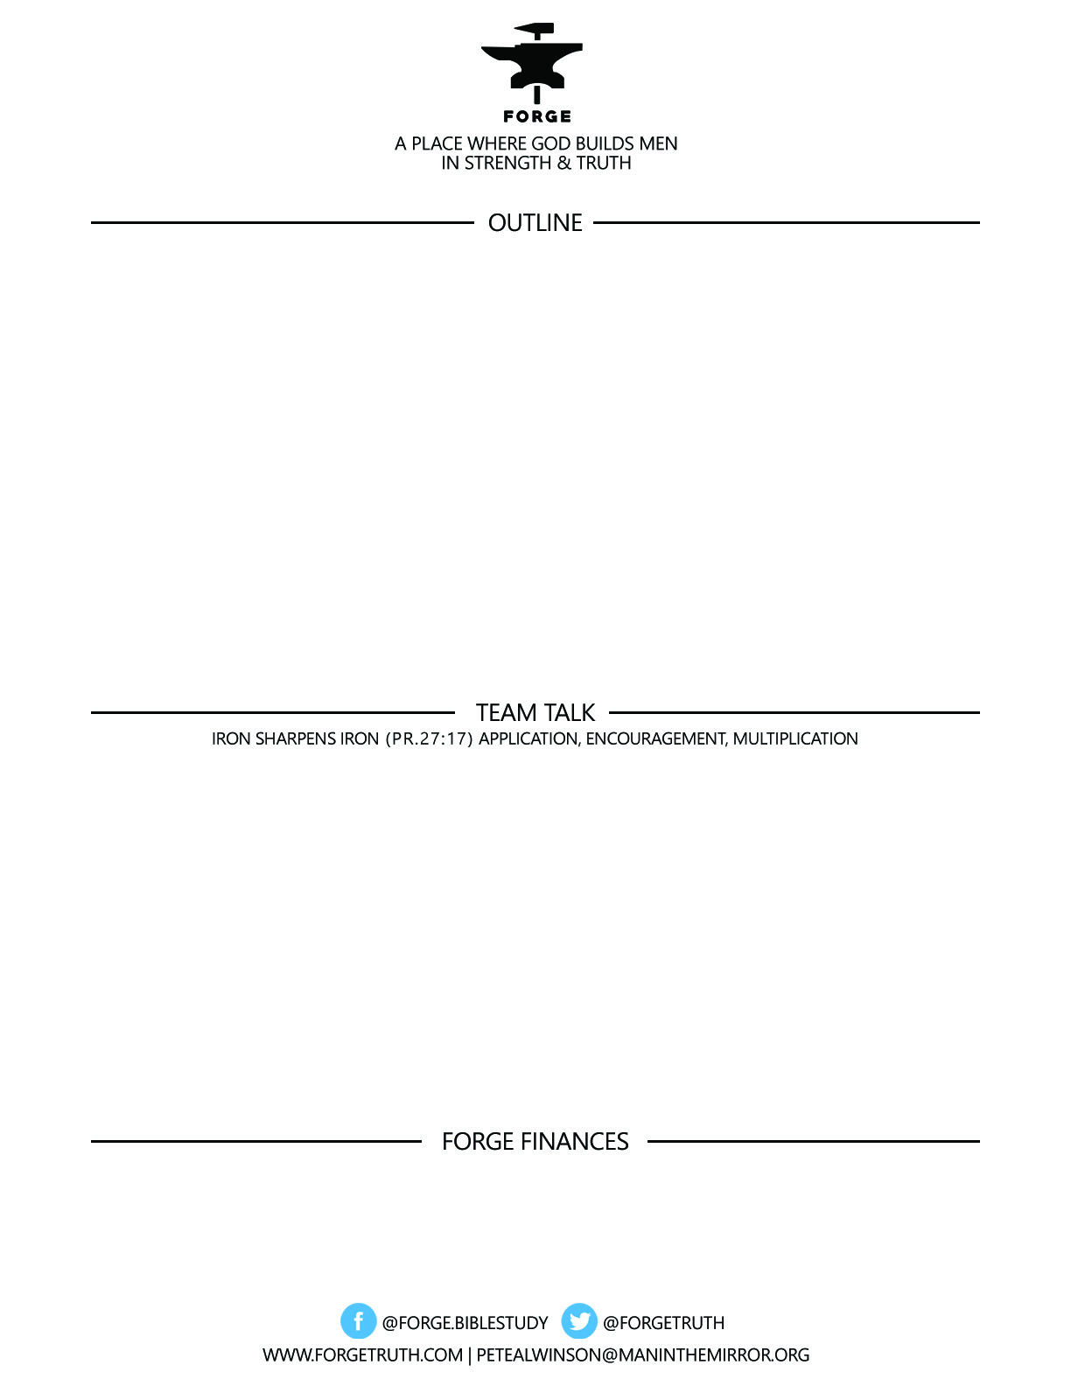

**TITANS FOR TODAY- Titus 1:1-9 PAUL’S ‘GO TO’ MAN**

1:1-4- GREETINGS MAN TO MAN

1:5-9-MEN THE GOSPEL NEEDS

***To become a partner:*** [***www.ForgeTruth.com....”donate***](http://www.ForgeTruth.com....)***” section.***

***Checks To: Man in the Mirror In Memo Line: FORGE***

1. WHAT DID YOU PICK UP IN THIS MESSAGE ABOUT PAUL AND TITUS’ RELATIONSHIP? HOW IS THIS SIGNIFICANT TO US IN THE CHURCH TODAY?
2. TALK THROUGH THE QUALIFICATIONS FOR LEADERSHIP AND THE GOALS FOR MATURE MANHOOD THAT PAUL LISTS IN 1:5-9…TALK ABOUT THOSE WHICH ARE THE MOST IMPORTANT TO YOU **RIGHT NOW** IN TERMS OF YOUR FOCUS FOR GROWTH AS A MAN.

ASK ONE GUY TO PRAY FOR THE MEN AT YOUR TABLE IN TERMS OF GROWTH IN THESE TRAITS BEFORE THE WRAP UP FOR THE DAY.