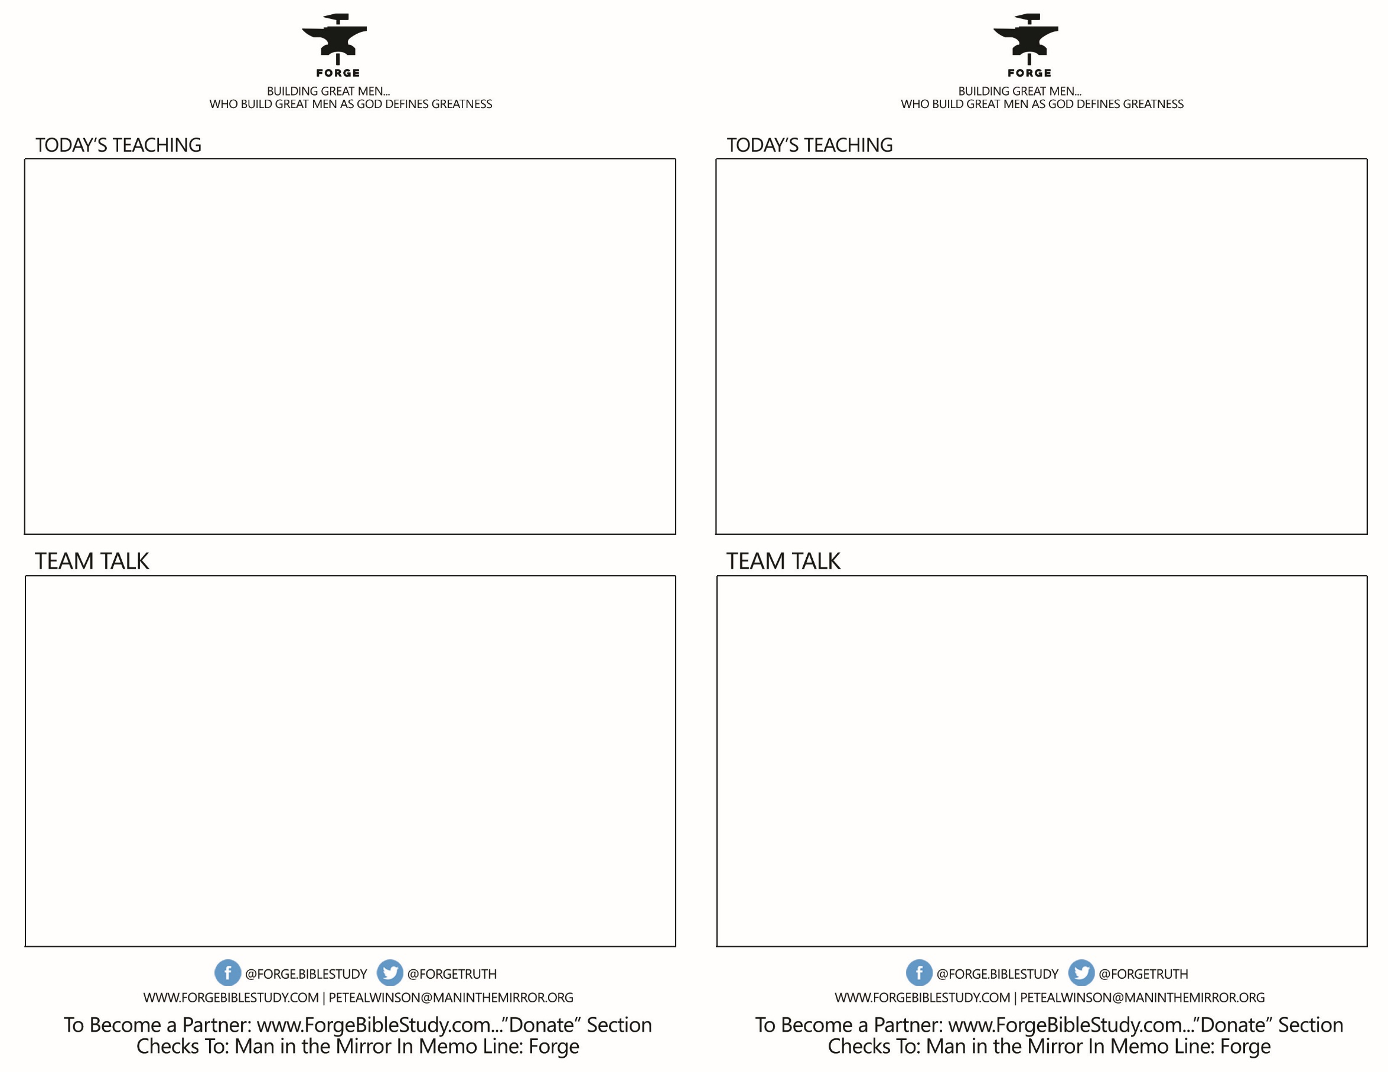

* WHO ARE THE PRIMARY PHLEGMATIC/AMIABLES AROUND YOUR TABLE?
* What has been your biggest challenge as a Phleg?
* How can a more mild mannered phlegmatic talk to his wife about her tendency to yell too much at the kids, or to curb her spending habits, or to try to keep a cleaner house (as examples).
* What language can a phlegmatic man use in dealing with a really strong son or daughter in order to give leadership and build their children into mature adults?
* How can a Phlegmatic man stand up for what is right in his church or business?
* WHO ARE THE PRIMARY PHLEGMATIC/AMIABLES AROUND YOUR TABLE?
* What has been your biggest challenge as a Phleg?
* How can a more mild mannered phlegmatic talk to his wife about her tendency to yell too much at the kids, or to curb her spending habits, or to try to keep a cleaner house (as examples).
* What language can a phlegmatic man use in dealing with a really strong son or daughter in order to give leadership and build their children into mature adults?
* How can a Phlegmatic man stand up for what is right in his church or business?

KNOWING YOURSELF- *How Men Grow Faster & Deeper*

*Talk 5 THE PHLEGMATIC/AMIABLE*

*Where does a Phleg Need to Grow...and How?*

1. *SPIRIT FILLING*
2. *AS A SON*
3. *AS A LEADER*
4. *AS A WORKER-PROVIDER*
5. *AS A WARRIOR-AMBASSADOR*

KNOWING YOURSELF- *How Men Grow Faster & Deeper*

*Talk 5 THE PHLEGMATIC/AMIABLE*

*Where does a Phleg Need to Grow...and How?*

1. *SPIRIT FILLING*
2. *AS A SON*
3. *AS A LEADER*
4. *AS A WORKER-PROVIDER*
5. *AS A WARRIOR-AMBASSADOR*