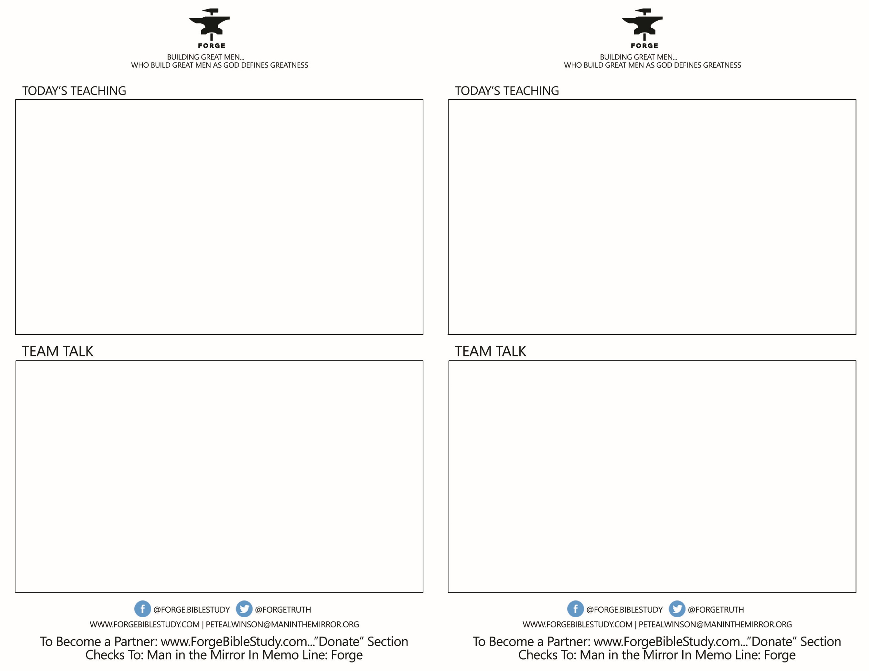

* Who around your table would self-identify as a primary melancholy/analytic? Who would have this as a secondary trait?
* How has this temperament helped you in life in work and relationships?
* How has it been challenging for you?
* If your wife has this temperament, how have you dealt with it? How has it helped you grow as a man?
* Do any of your children have this temperament?
* Why do we need Melancholy/Analytics in the church?
* Who around your table would self-identify as a primary melancholy/analytic? Who would have this as a secondary trait?
* How has this temperament helped you in life in work and relationships?
* How has it been challenging for you?
* If your wife has this temperament, how have you dealt with it? How has it helped you grow as a man?
* Do any of your children have this temperament?
* Why do we need Melancholy/Analytics in the church?

KNOWING YOURSELF- *How Men Grow Faster & Deeper*

*Talk 4 The Melancholy/Analytic*

* *Ask to be filled with the Holy Spirit*
* *Recognize your tendencies- “Know Thyself” (Socretes)*
* *Because you want to be right...*
* *Because you are so self- sacrificing...*
* *Because you can get moody...*
* *Because you tend to be a perfectionist..*

KNOWING YOURSELF- *How Men Grow Faster & Deeper*

*Talk 4 The Melancholy/Analytic*

* *Ask to be filled with the Holy Spirit*
* *Recognize your tendencies- “Know Thyself” (Socretes)*
* *Because you want to be right...*
* *Because you are so self- sacrificing...*
* *Because you can get moody...*
* *Because you tend to be a perfectionist...*