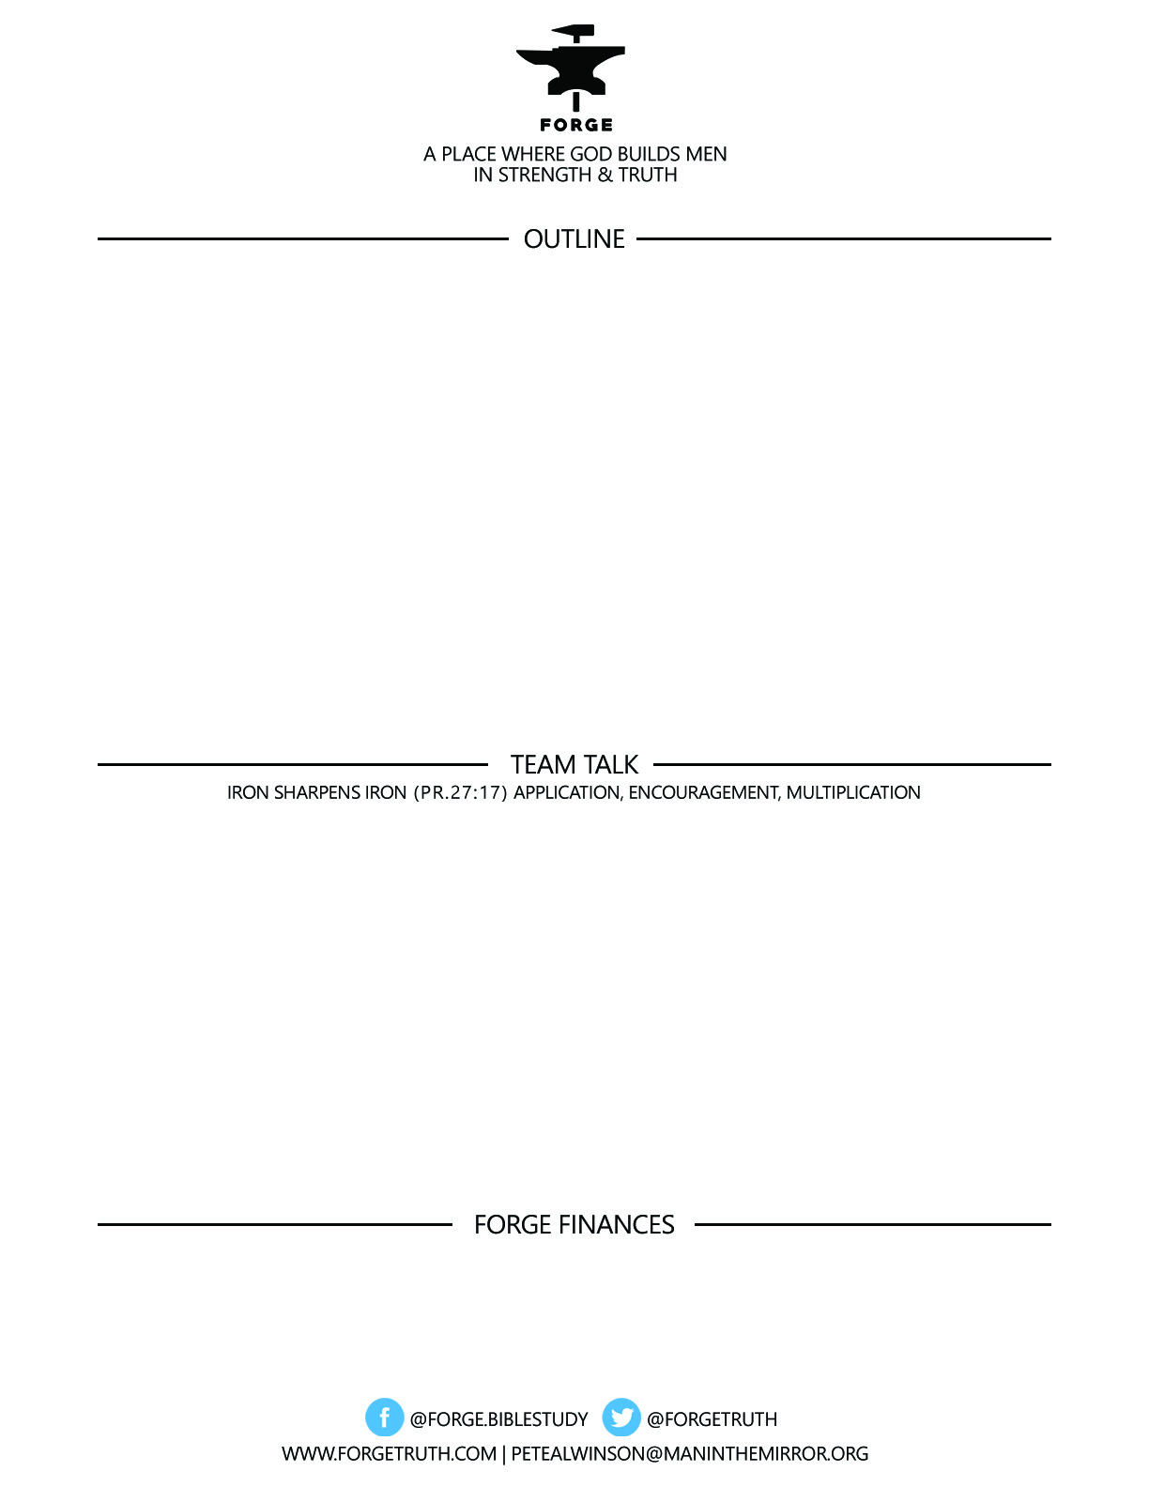

***GREAT MEN GREATER GOD SERIES***

***Knowing & Experiencing the God Who Is FORGES Men of Distinction***

**Talk 7 THE LOVE AND GOODNESS OF GOD**

***To become a partner:*** [***www.ForgeTruth.com....”donate***](http://www.ForgeTruth.com....)***” section.***

***Checks To: Man in the Mirror In Memo Line: FORGE***

1. WHAT STANDS OUT TO YOU ABOUT THE LOVE AND GOODNESS OF GOD FROM TODAY’S TALK?
2. WHAT DO MEN STRUGGLE WITH ABOUT MOST ABOUT THE LOVE AND GOODNESS OF GOD?
3. HOW CAN WE MEN HELP EACH OTHER GROW STRONGER BY FOCUSING ON THE LOVE & GOODNESS OF GOD?