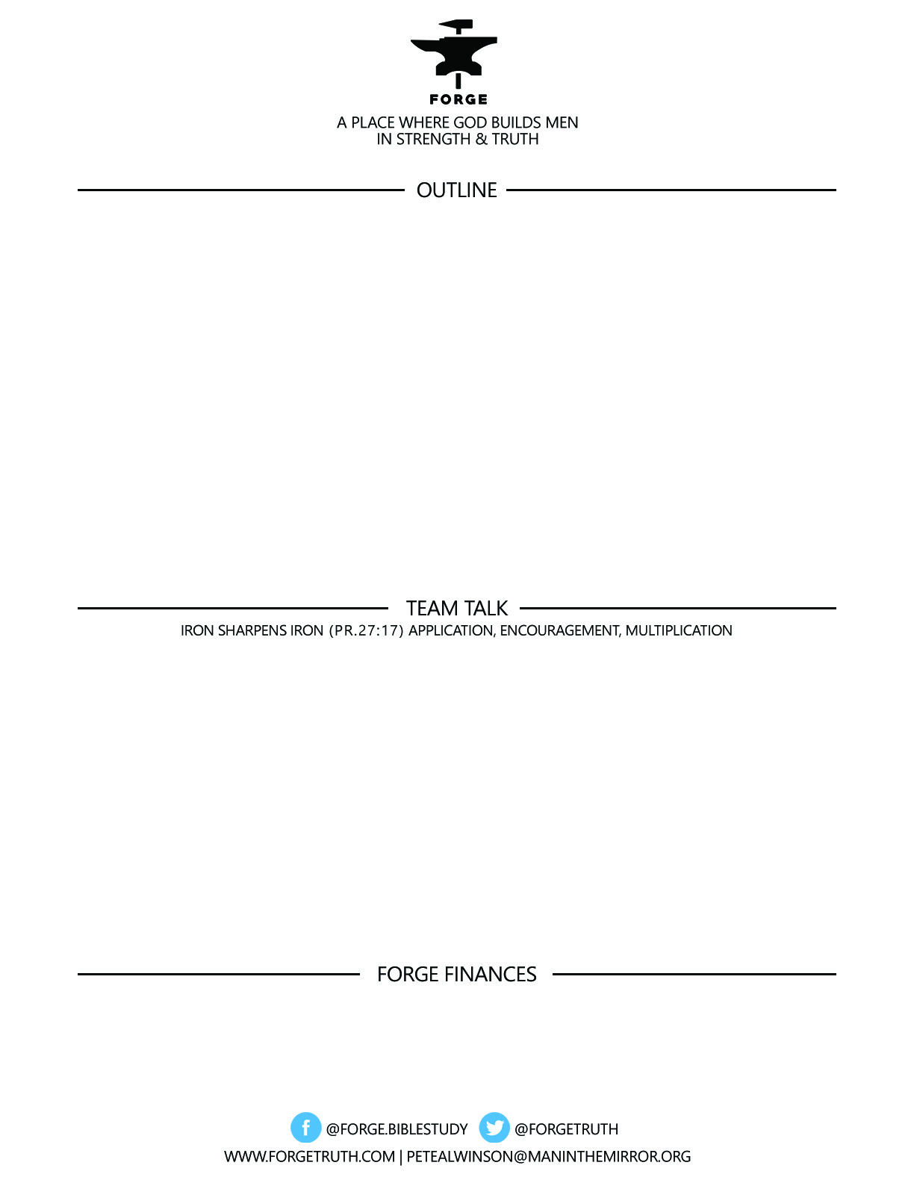

***GREAT MEN GREATER GOD SERIES-Talk 2-HOW SHOULD I USE MY POWER? January 16, 17, 18-2018***

# ***MSM:*** Romans 1:20

**20**For his invisible attributes, namely, his eternal power and divine nature, have been clearly perceived, ever since the creation of the world,[[a](https://www.biblegateway.com/passage/?search=Romans+1%3A20&version=ESV#fen-ESV-27935a)] in the things that have been made. So they are without excuse.

1. ***THE GOD OF POWER***
2. ***HOW GOD USES HIS POWER***
3. ***HOW HIS SONS SHOULD USE POWER***

***To become a partner:*** [***www.ForgeTruth.com....”donate***](http://www.ForgeTruth.com....)***” section.***

***Checks To: Man in the Mirror In Memo Line: FORGE***

1. How does it make you feel to know that God is All powerful?
2. What stood out to you about how God uses His power?
3. How would you like to use your power as a man in a manner more like God uses His power?