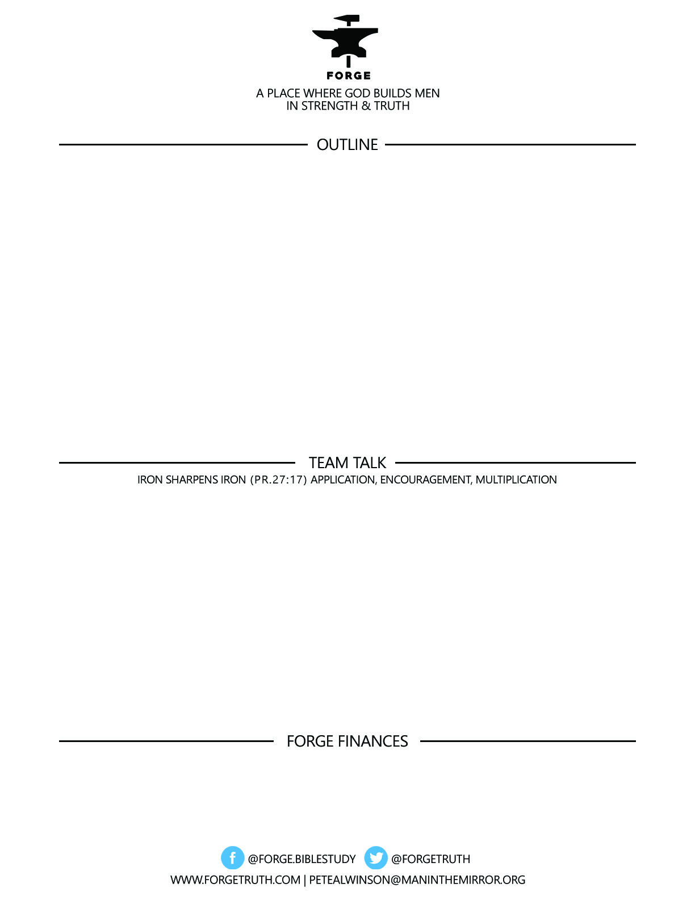

**GREAT MEN GREATER GOD SERIES: The Attributes of God**

***Knowing & Experiencing the God Who Is FORGES Men of Distinction***

***What are the attributes of God?***

***A.W. Tozer: “What comes into our minds when we think about God is the most important thing about us.”***

***Romans 1:20***

***Exodus 3:14***

***John 5:25-27***

***2 Corinthians 5:14-21***

***To become a partner:*** [***www.ForgeTruth.com....”donate***](http://www.ForgeTruth.com....)***” section.***

***Checks To: Man in the Mirror In Memo Line: FORGE***

1. Clarify around the table what we mean by “the attributes of God”- make sure everyone understand this important concept.
2. What does the Self-Existence of God really mean? Discuss the implications that God is Self-Existent.
3. How can we as The Father’s Sons through Christ experience the reality of God’s Self-Existence? How can this big concept make a difference in our lives and challenge and change us? In other words, how does the fact that God is Greater than us, make us men of distinction?