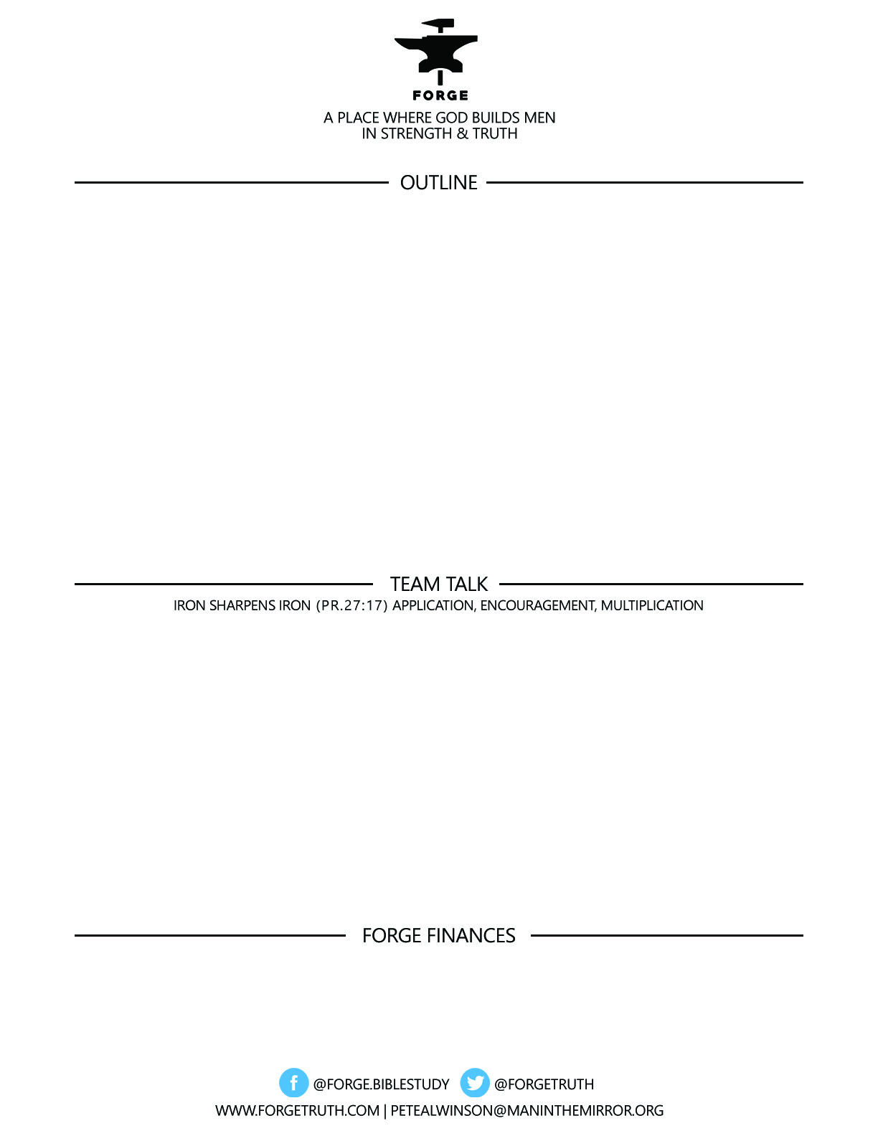

**IN THE STEPS OF GIANTS**

***His name is…. Blaise__________:***

***V. THE AGE OF REASON AND REVIVAL: 1648-1789***

***And then there was John____________:***

***VI. THE AGE OF PROGRESS: 1789-1914***

***Matthew 13:31-32***

***To become a partner:*** [***www.ForgeTruth.com....”donate***](http://www.ForgeTruth.com....)***” section.***

***Checks To: Man in the Mirror In Memo Line: FORGE***

1. What did you learn about the Age of Reason that helps you understand our present time?
2. Which strong men of the period of Revival stand out to you as important heroes for Christian Men today?
3. How does the Parable of the Mustard Seed in Matthew 13:31-32 guide us as Christian men in a chaotic time, and how does it help us keep focused on Matthew 28:18-20?