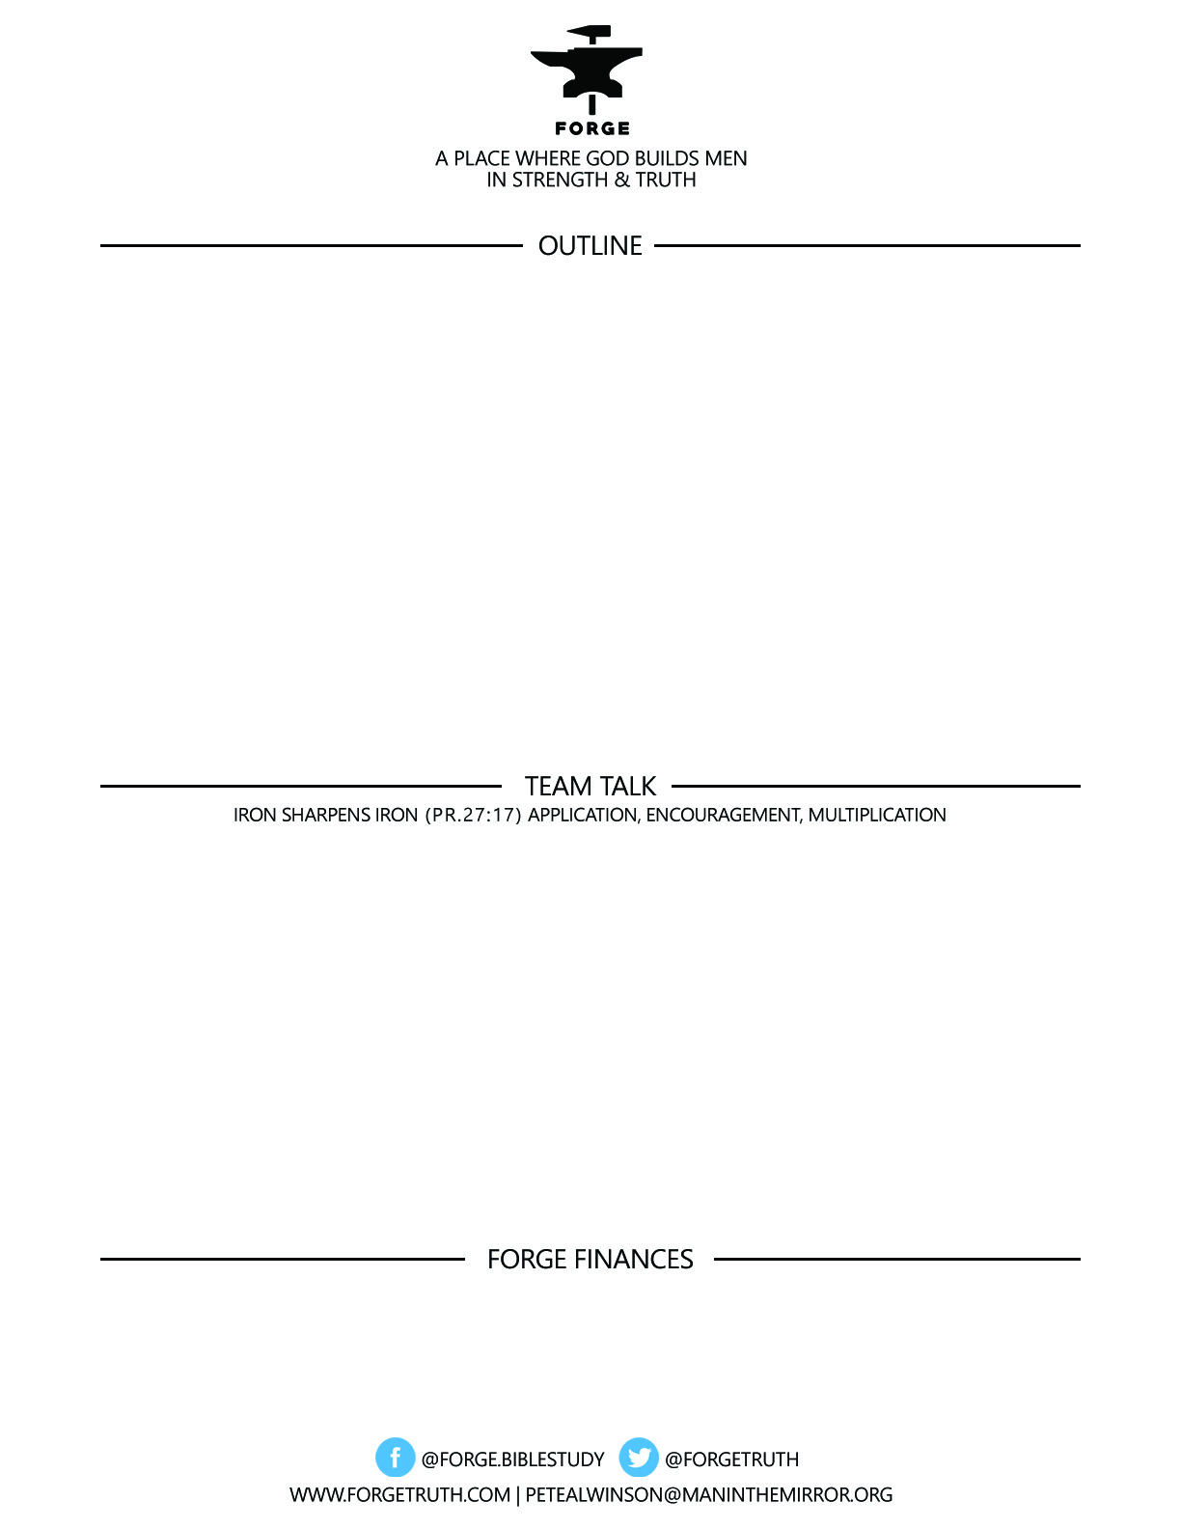

**IN THE STEPS OF GIANTS- Forge October 31 and November 2**

1. ***THE AGE OF JESUS AND THE APOSTLES- 6BC-70 AD***
2. ***THE AGE OF CATHOLIC CHRISTIANITY-70-312***

***III. THE AGE OF THE CHRISTIAN ROMAN EMPIRE: 312-590***

***IV. THE CHRISTIAN MIDDLE AGES: 590-1517***

***VI. THE AGE OF THE REFORMATION: 1517-1648***

***To become a partner:*** [***www.ForgeTruth.com....”donate***](http://www.ForgeTruth.com....”donate)***” section.***

***Checks To: Man in the Mirror In Memo Line: FORGE***

1. In the AGE OF THE CHRISTIAN ROMAN EMPIRE-312-590- Were you shocked by the amount of controversy over doctrinal issues concerning Jesus and the Trinity? Why or why not? Do you think the average Christian was involved in these discussion or was it just the conversation for some of the more intellectual leaders? Ultimately, what was at stake in these discussions about Jesus and the Trinity? Why should Christ following men be concerned for Truth and an accurate understanding of Biblical teaching?
2. In the AGE OF THE REFORMATION-1517-1648- What stood out to you personally in this era of reform and particularly in the account of Martin Luther? How is Martin Luther for you a Christian male role model?