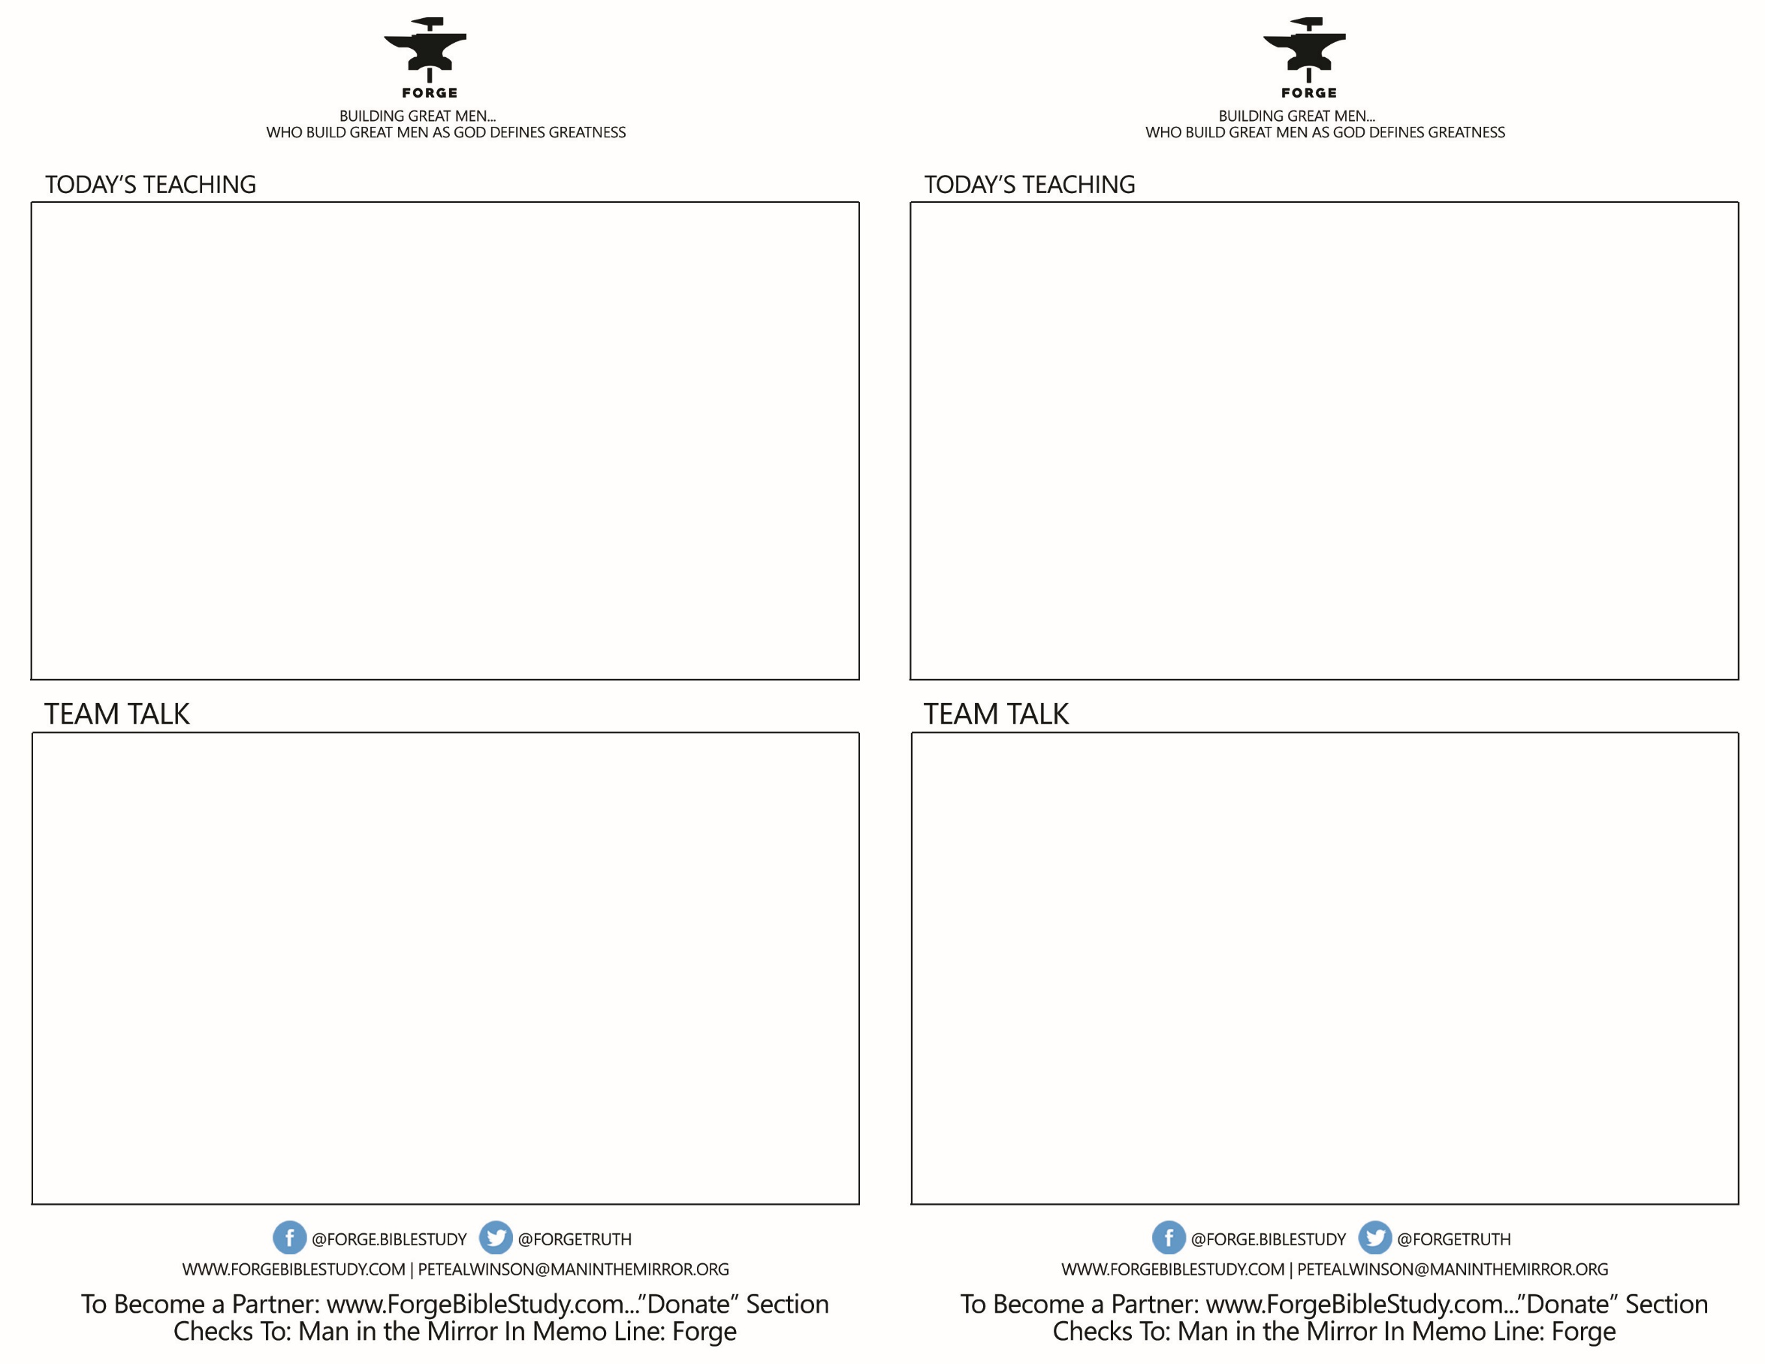

* Look up Psalm 141:5- How does it apply to a man’s growth?
* Read Proverbs 19:4,6-7-What type of guys do we often want to be our friends?
* Interact with this statement: “Fire Teams don’t give me an identity, they reinforce my identity.” Why should this be true?
* How can a Christian guy who doesn’t like people much and/or is introverted have a Fire Team? Is it impossible?
* Read I Corinthians 15:33- What does this say about who should be influential in our lives? Do you have anyone that’s got to go? (You don’t have to announce this out loud!)
* Look up Psalm 141:5- How does it apply to a man’s growth?
* Read Proverbs 19:4,6-7-What type of guys do we often want to be our friends?
* Interact with this statement: “Fire Teams don’t give me an identity, they reinforce my identity.” Why should this be true?
* How can a Christian guy who doesn’t like people much and/or is introverted have a Fire Team? Is it impossible?
* Read I Corinthians 15:33- What does this say about who should be influential in our lives? Do you have anyone that’s got to go? (You don’t have to announce this out loud!)

**FIRE TEAM BASICS: List, Pray, Meet**

**FIRE TEAM QUESTIONS:**

What spiritual successes have you had this past week? What’s going right?

What Biblical insights has the Father given you from your DAWG or from some other source? What are you learning now?

Where are you growing/struggling as a Son, Leader, Worker-Provider, Warrior-Ambassador of Jesus Christ?

How Can I fight for you?

**FIRE TEAM BASICS: List, Pray, Meet**

**FIRE TEAM QUESTIONS:**

What spiritual successes have you had this past week? What’s going right?

What Biblical insights has the Father given you from your DAWG or from some other source? What are you learning now?

Where are you growing/struggling as a Son, Leader, Worker-Provider, Warrior-Ambassador of Jesus Christ?

How Can I fight for you?