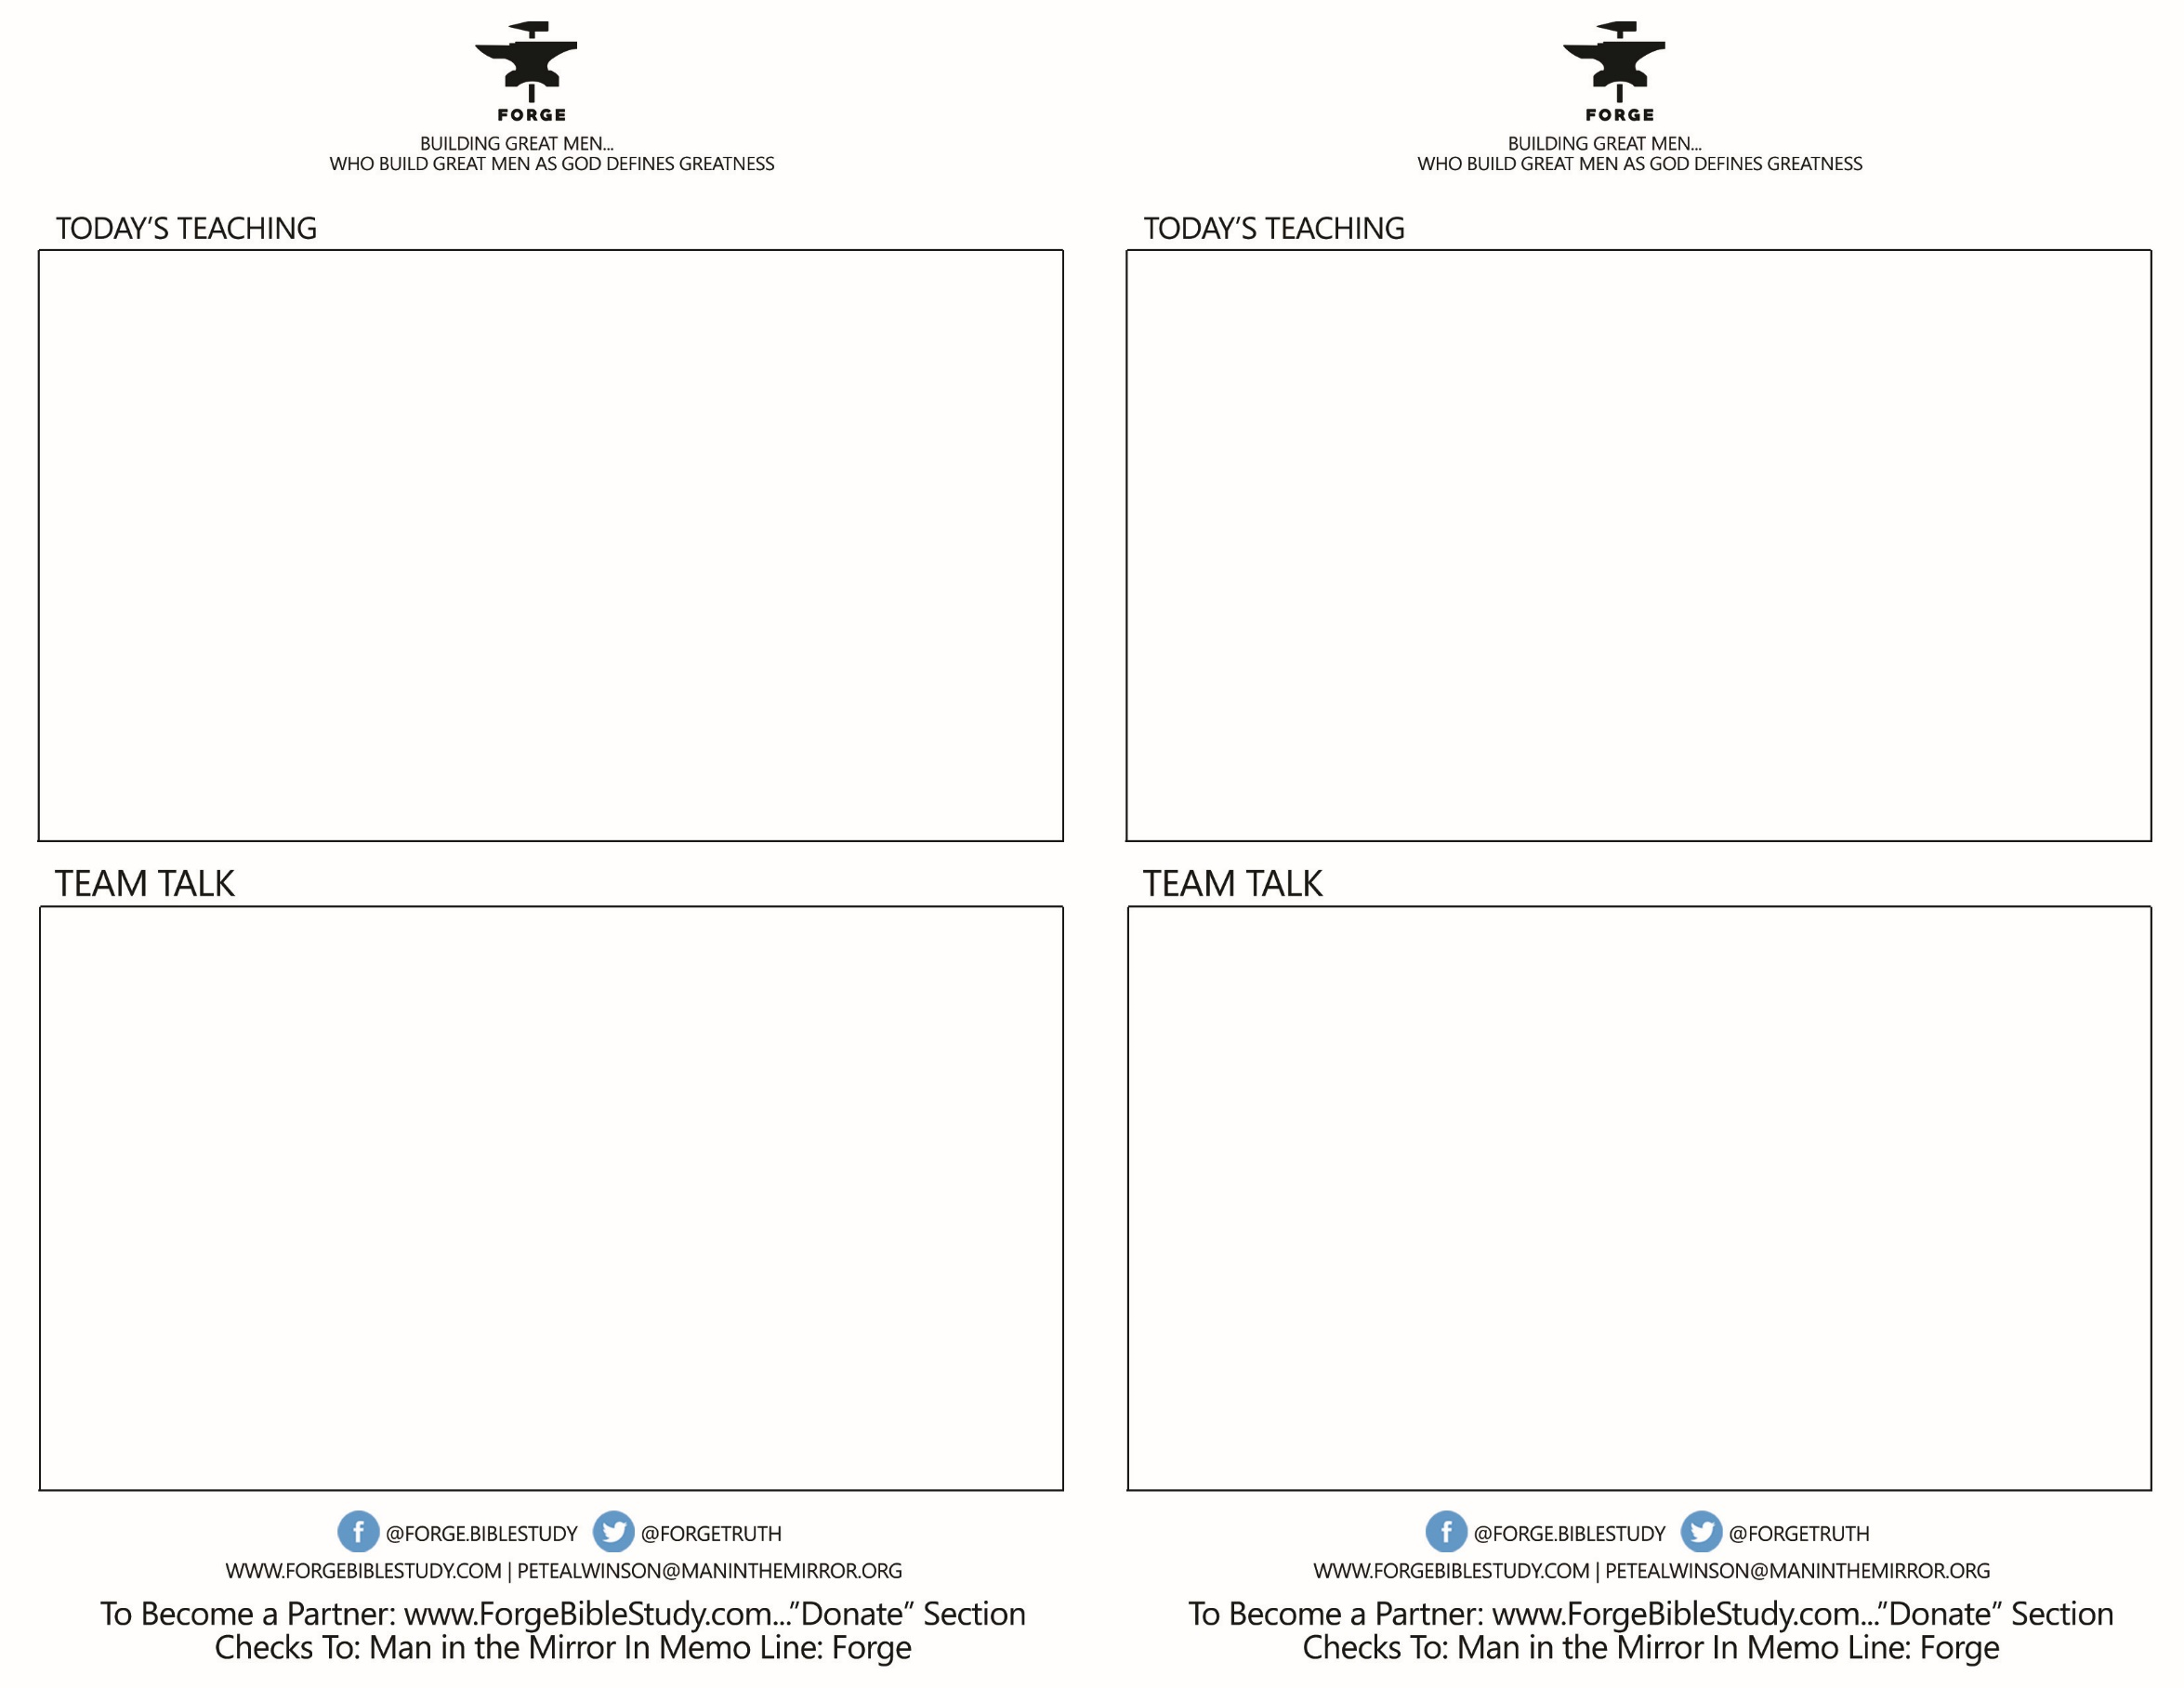

* What stood out to you about how Jesus built the disciples? Was there anything new to you today as we discussed His process? How can we today employ this same model with new Christ followers or those younger in the faith?
* How did the Disciples become brothers as they followed Jesus together?
* In learning what a FIRE TEAM is not ,does this begin to clarify what a FIRE TEAM can be?
* What thoughts on brotherhood did you pick up today?
* What stood out to you about how Jesus built the disciples? Was there anything new to you today as we discussed His process? How can we today employ this same model with new Christ followers or those younger in the faith?
* How did the Disciples become brothers as they followed Jesus together?
* In learning what a FIRE TEAM is not ,does this begin to clarify what a FIRE TEAM can be?
* What thoughts on brotherhood did you pick up today?

**FORGE FIRE TEAMS- Talk 3**

***How Jesus Built Men- Mark 1 & 2 Selected***

***What a Fire Team is Not: 1) A Couple’s group, but a band of brothers 2) Not a 2-hr. Bible study but a one hour breakfast, lunch or phone call. 3) Not an evening away from your family, but an hour from your work day or before work. 4) Not 6-8 guys- but 2-4. 5) Not focused on learning, but focused on fighting 6) Not a meeting agenda that generates opinions, but a meet agenda that generates brothers.***

*Got Your Back, by Gary Yagel- p. 81-82*

**FORGE FIRE TEAMS- Talk 3**

***How Jesus Built Men- Mark 1 & 2 Selected***

***What a Fire Team is Not: 1) A Couple’s group, but a band of brothers 2) Not a 2-hr. Bible study but a one hour breakfast, lunch or phone call. 3) Not an evening away from your family, but an hour from your work day or before work. 4) Not 6-8 guys- but 2-4. 5) Not focused on learning, but focused on fighting 6) Not a meeting agenda that generates opinions, but a meet agenda that generates brothers.***

*Got Your Back, by Gary Yagel- p. 81-82*