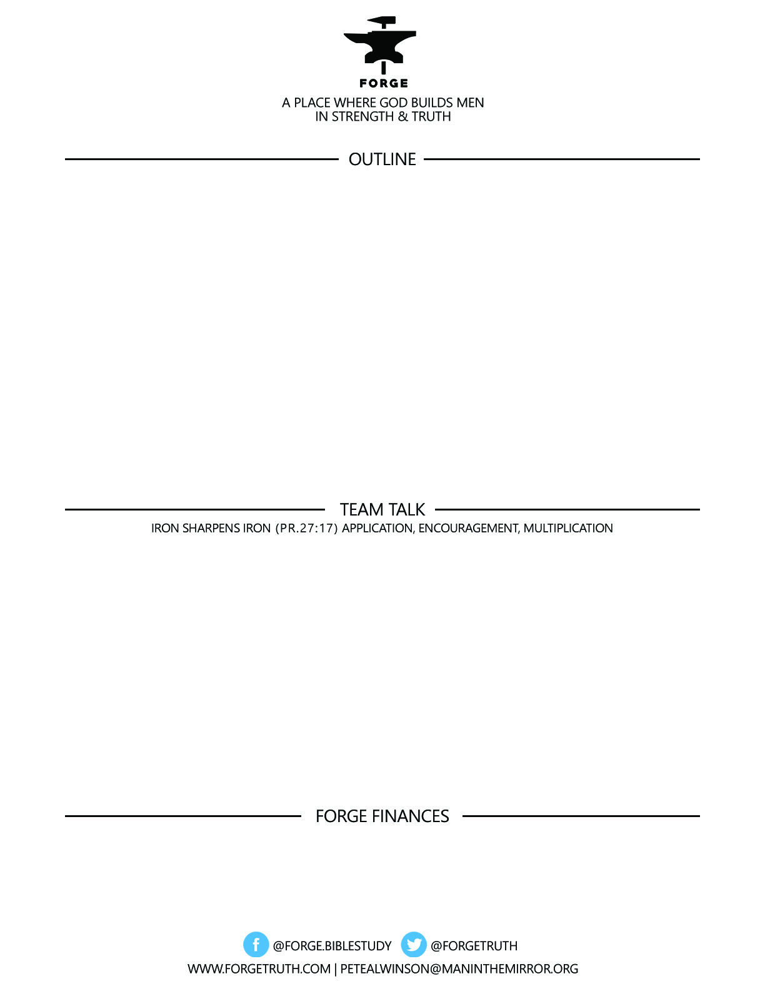

**ECCLESIASTES REAL & RAW- *The Life That Is And the Way to Live It Talk 7***

***BUILDING A LIFE IN A PRECARIOUS WORLD…Part 1***

1. ***NEVER UNDERESTIMATE THE IMPACT OF ONE FOOL: Ecc. 10:1-7; 12-20***
2. ***GET A HOLD OF THIS TENSION- ACCIDENTS HAPPEN-TAKE RISKS ANYWAY: 10:8-11***
3. ***BE GENEROUS-AND A WISE INVESTOR: Ecc. 11:1-2***

***To become a partner:*** [***www.ForgeTruth.com....”donate***](http://www.ForgeTruth.com....)***” section.***

***Checks To: Man in the Mirror In Memo Line: FORGE***

1. WHAT NEGATIVE EXPERIENCES HAVE YOU HAD WITH PEOPLE YOU COULD ONLY, FINALLY DESCRIBE AS A FOOL? WHAT DID YOU LEARN FROM THAT EXPERIENCE?
2. From Point 2 above: Have bad experiences turned you away from taking risks in life? How can we learn from bad experiences without turning off risk taking in our lives? Why is it important that Christ-following men take some risks?
3. WHAT STANDS OUT TO YOU AS IMPORTANT FROM ECC. 11:1-2?