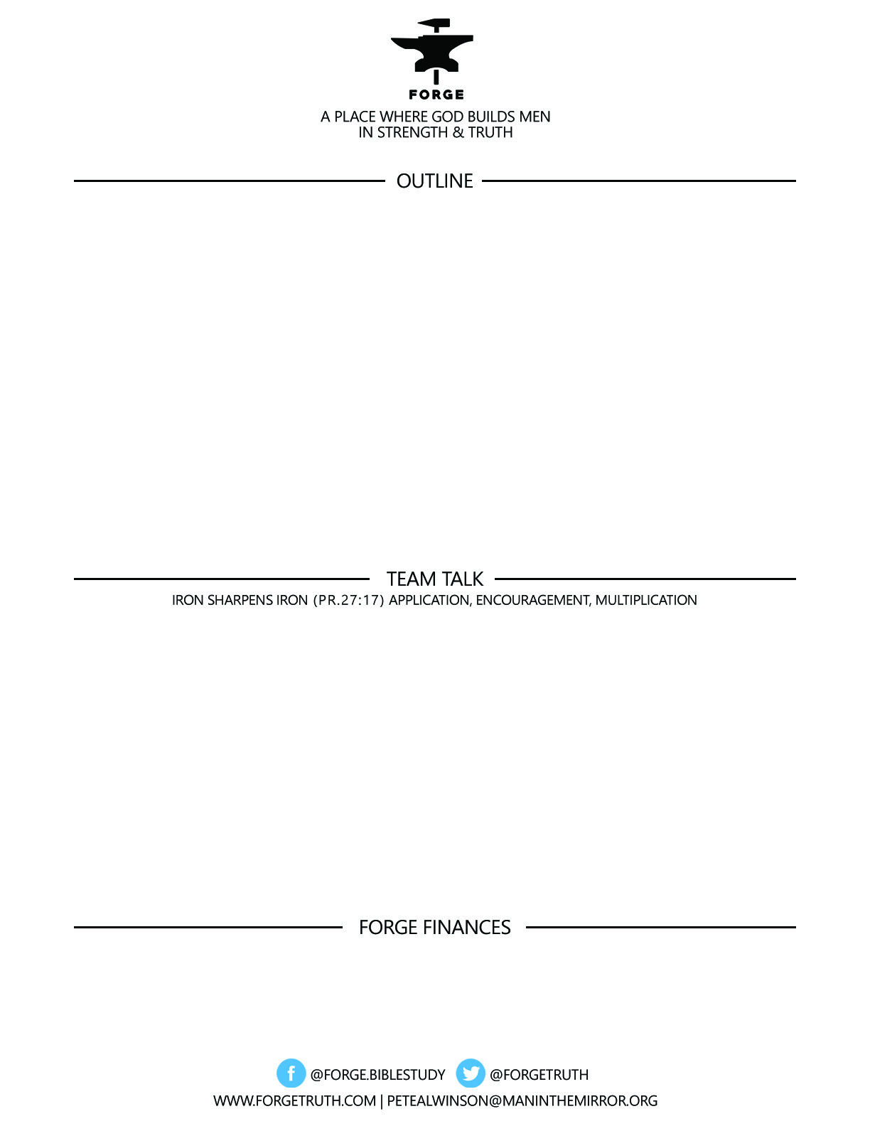

**ECCLESIASTES: REAL & RAW-*The Life That Is and the Way to Live It*-**

**Talk 4 BEATING THE BULLY-What To Do When You Don’t See the Out**

**Ecclesiastes 5:1-20**

1. WORSHIP: 5:1
2. LISTEN: 5:1
3. PRAY: 5:2-7
4. WAIT: 5:8-20

***To become a partner:*** [***www.ForgeTruth.com....”donate***](http://www.ForgeTruth.com....)***” section.***

***Checks To: Man in the Mirror In Memo Line: FORGE***

**Talk a minute around your table about worship:** Is worshipping God something you as a man find easy to do? Why do you find it satisfying or why do you find it difficult? What bit of advice can you offer to the guys at your table about how worship has become a building place for your spiritual life?

**Listening to God:** Men are notoriously bad listeners. How have you learned to listen to God’s voice? What role does reading the Bible play in hearing His voice?

**Prayer:** What is Solomon’s advice concerning prayer? If you get this far, what have you learned about praying that can help the other guys at your table?

**Waiting:** What have you learned about waiting on God?