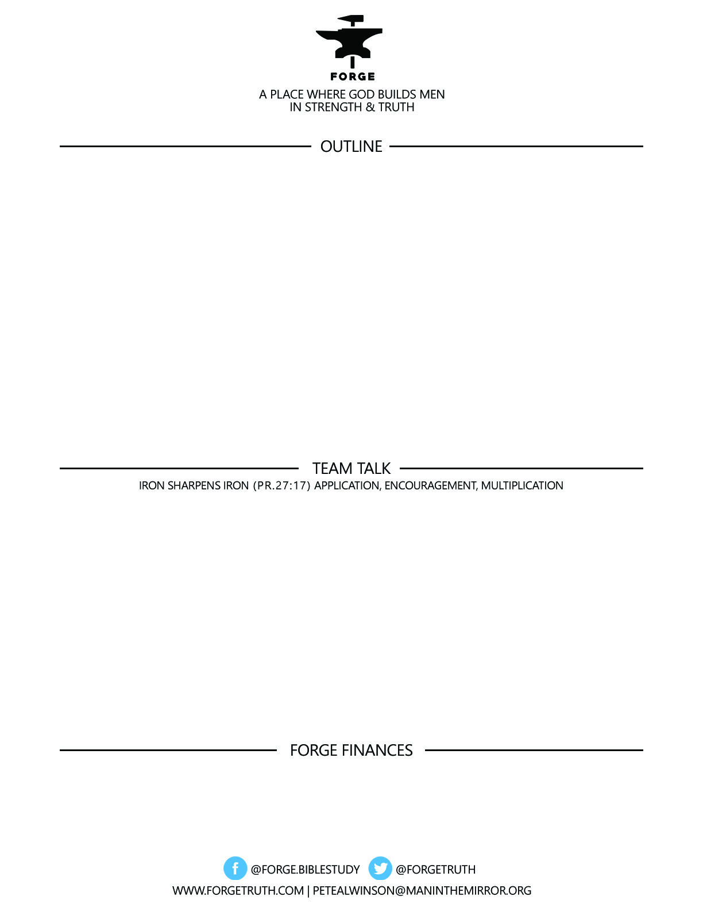

**ECCLESIASTES: REAL & RAW-*The Life That Is and the Way to Live It*- 4/17/18**

**Talk 3: CONFIDENCE IN THE FACE OF BADNESS**

1. **INJUSTICE: 3:16-22**
2. **OPPRESSION: 4:1-3**
3. **ENVY & COMPETITION: 4:4-16**

***To become a partner:*** [***www.ForgeTruth.com....”donate***](http://www.ForgeTruth.com....)***” section.***

***Checks To: Man in the Mirror In Memo Line: FORGE***

1. **INJUSTICE:** CONNECTION: WHERE HAVE YOU EXPERIENCED INJUSTICE…OR…WHERE HAVE YOU CAUSED IT?!

WHAT DID YOU LEARN ABOUT INJUSTICE FROM SOLOMON?

1. **OPPRESSION:** DOES SOLOMON GIVE ANY GOD ANSWERS TO THE PROBLEM OF OPPRESSION? WHAT DID YOU LEARN ABOUT THE OPPRESSED?
2. **ENVY & COMPETITION:** DO YOU AGREE THAT MUCH OF OUR WORK STEMS FROM ENVY? WHY? WHY NOT? WHAT KEY TEACHING STOOD OUT FOR YOU ABOUT MEN AND WORK FROM 4:4-16