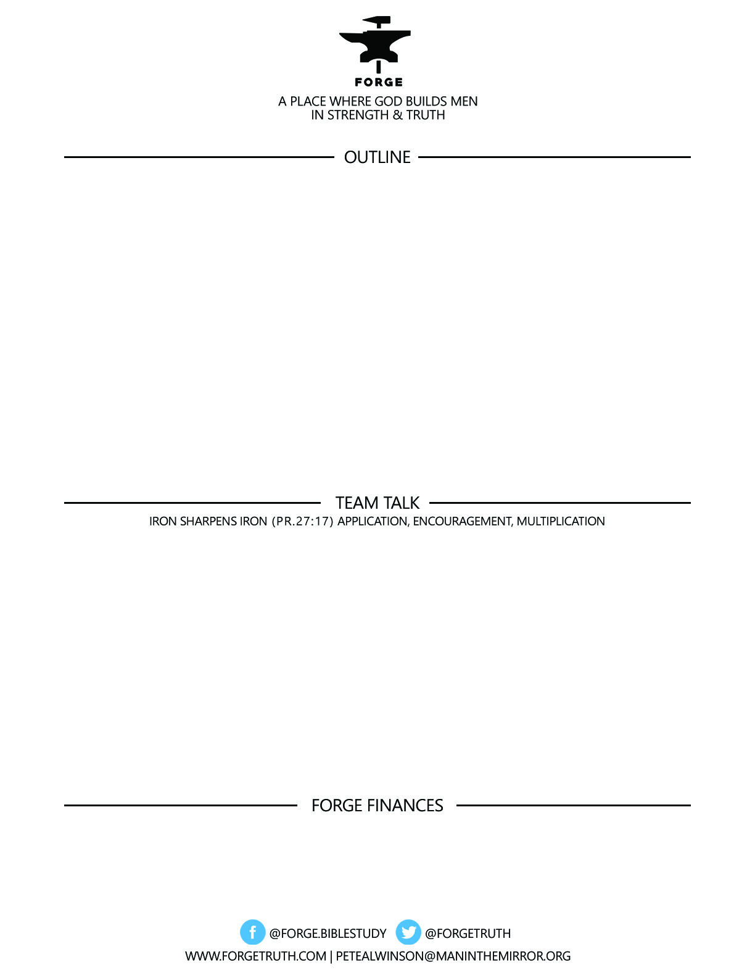

**ECCLESIASTES: REAL & RAW-*The Life That Is and the Way to Live It-Talk 2***

***BEHIND THE CURTAIN-WHO CALL’S THE SHOTS!***

***Ecclesiastes 3***

1. ***EVIDENCE OF SOVEREIGNTY***
2. ***WRESTLING WITH SOVEREIGNTY***
3. ***ADJUSTING TO SOVEREIGNTY***

***To become a partner:*** [***www.ForgeTruth.com....”donate***](http://www.ForgeTruth.com....)***” section.***

***Checks To: Man in the Mirror In Memo Line: FORGE***

1. Is the word SOVEREIGNTY one you’re familiar with in the church environment you grew up in?
2. How was it defined in the talk today?
3. Why do we American’s tend to struggle with the Biblical teaching on the Sovereignty of God?
4. How does the truth of SOVEREIGNTY help us as men being men follow Christ?