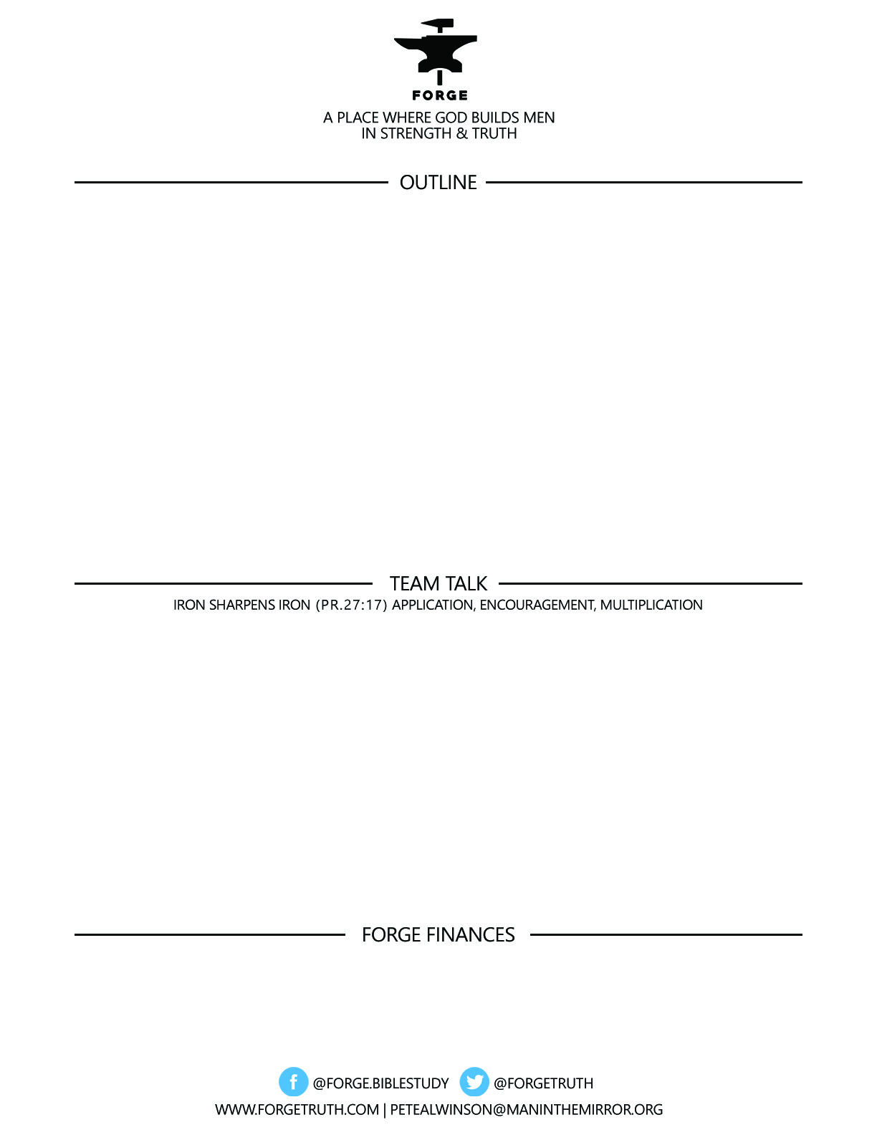

**ECCLESIASTES: REAL & RAW *The Life That Is and the Way to Live It*------*Talk 1***

**SHATTERING THE MYSTIQUE--What Can Life Really Do For you?**

**Ecclesiastes 1:1-13**

***To become a partner:*** [***www.ForgeTruth.com....”donate***](http://www.ForgeTruth.com....)***” section.***

***Checks To: Man in the Mirror In Memo Line: FORGE***

1. WHAT DID YOU PICK UP FROM THE TALK TODAY ABOUT HOW WE SHOULD INTERPRET ECCLESIASTES? WHO ARE THE KEY PLAYERS?
2. HAVE YOU ASKED SOME OF THE QUESTIONS THAT THE TEACHER ASKS IN THE VERSES WE LOOKED AT TODAY? Specifically: Have you ever felt that all of life was meaningless?( 2) What made you feel that way? Have you ever felt just so tired that doing the slightest work was “wearisome” (v8)? Does the Teacher give any answers in this passage today?
3. Pray for each other around the table today—for 1 struggle/challenge each-share briefly and pray succinctly!