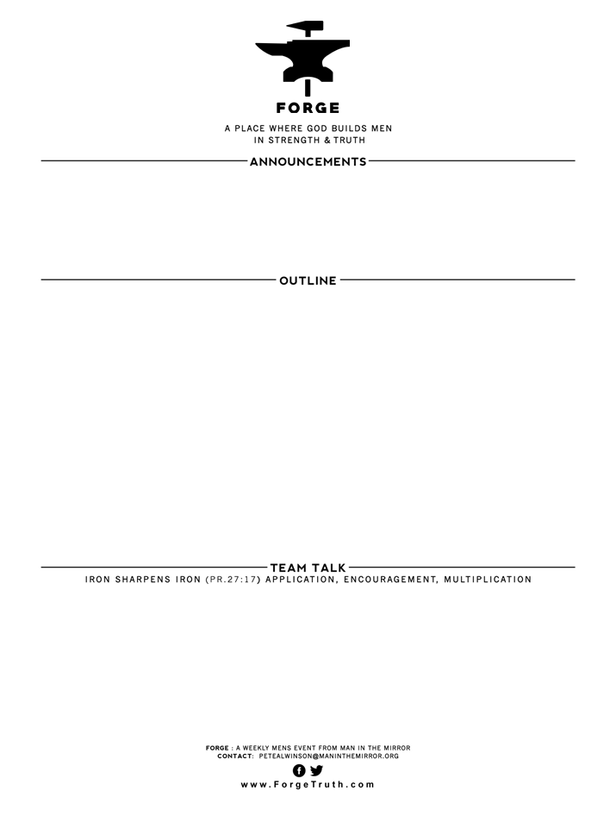

DADS THAT MAKE A DIFFFERENCE Session 1

What is Fathering Anyway?

1. What Culture Says
2. A Biblical Example: David
3. Fathering-A Biblical Definition

_______________ children to ___________ & _____________

1. Personal Examples of Fathering
2. Which of the words you wrote about your father has had the greatest impact on your life as a man? How have you seen that in your life as an adult? In other relationships? As a father?
3. David allowed temptation to distract him from discipling his children. What are the temptations that tend to pull you away as a father?
4. How would you rate yourself against the goal of “discipling our children to love God and others?” What are you doing that is helping to achieve this goal? How can you improve?

**WELCOME TO FORGE! FORGE DOWNTOWN STARTS: JANUARY 10, 2018**

* **Want our Eblasts? Sign up:** [**www.ForgeTruth.com**](http://www.ForgeTruth.com)
* **Want to view a message you missed:** [**www.ForgeTruth.com**](http://www.ForgeTruth.com)
* **Today: First Timers; Coffee & Lights ($3-5); let’s go!**