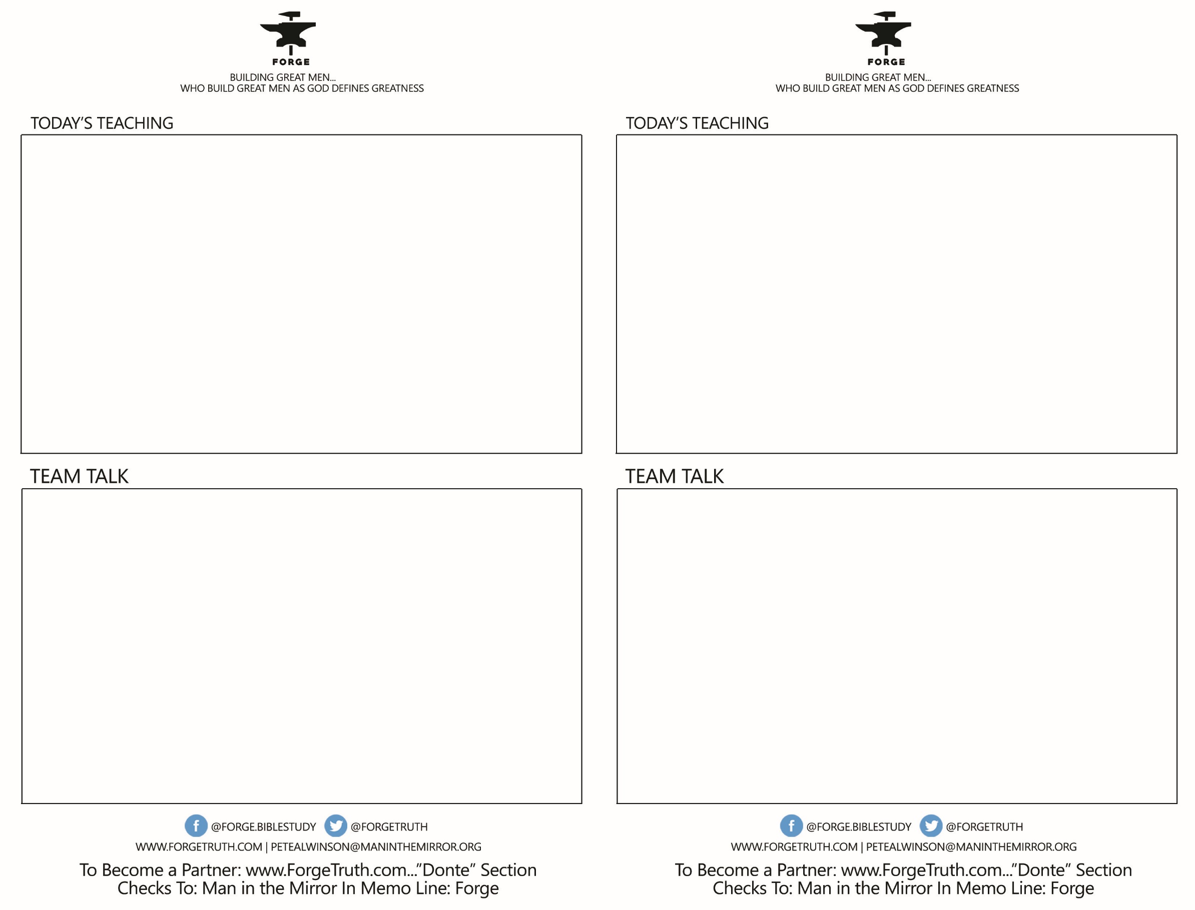

* I Thessalonians 2:13- What did you pick up about the Word of God, The Bible, that is important? Go around the table and talk about what you’ve been reading lately in the Bible (if you have), and what you find difficult/challenging about reading the Bible.
* I Thessalonians 2:14-19- How lately or in the past have you grown stronger by going through conflict or struggle or trial or suffering? Why is it true that we tend not to get stronger in good times? Why do we resent difficult times so much?
* I Thessalonians 3:1-13- If you get to this point to discuss, what are some simple –emphasis SIMPLE ways that we can encourage each other in this great and challenging journey of following Jesus and being built Jesus Tough?
* I Thessalonians 2:13- What did you pick up about the Word of God, The Bible, that is important? Go around the table and talk about what you’ve been reading lately in the Bible (if you have), and what you find difficult/challenging about reading the Bible.
* I Thessalonians 2:14-19- How lately or in the past have you grown stronger by going through conflict or struggle or trial or suffering? Why is it true that we tend not to get stronger in good times? Why do we resent difficult times so much?
* I Thessalonians 3:1-13- If you get to this point to discuss, what are some simple –emphasis SIMPLE ways that we can encourage each other in this great and challenging journey of following Jesus and being built Jesus Tough?

BUILDING MEN! WHY IT’S IMPORANT & HOW IT’S DONE Talk 4- I Thess 2-3

AUTHORITY

CONFLICT

CONNECTION

BUILDING MEN! WHY IT’S IMPORANT & HOW IT’S DONE Talk 4- I Thess 2-3

AUTHORITY

CONFLICT

CONNECTION