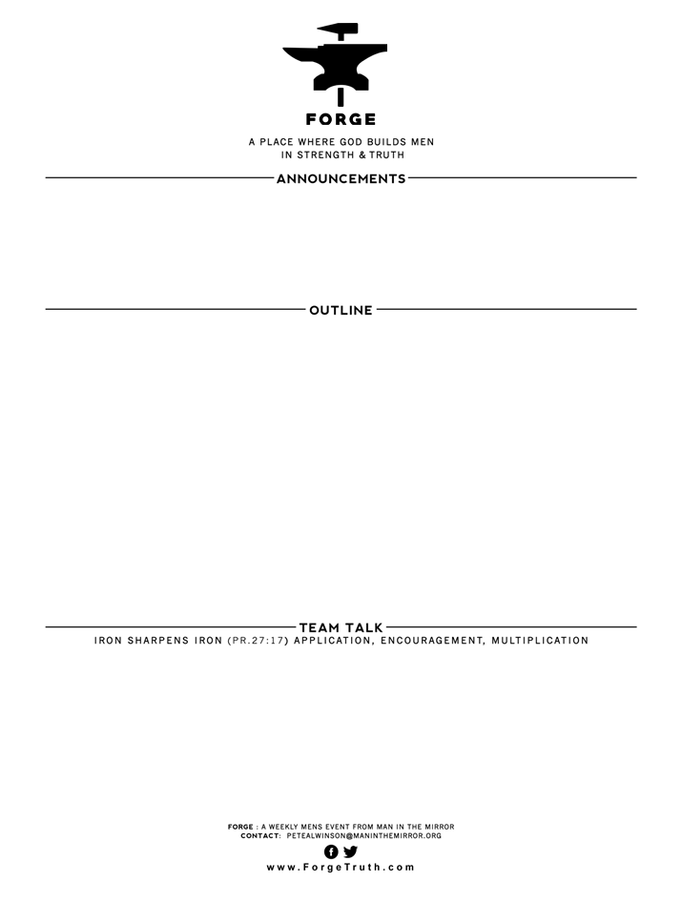

DISCIPLING YOUR WIFE! Ephesians 5:21-33  ESV

1. You must be a disciple first - Becoming like Jesus
2. You must submit yourself to your wife for her spiritual growth

3) Discipling your wife is for your own good - the two are one

Questions:

1) What did you hear that challenges your understanding of the relationship between a husband and wife?

2) What is the hardest part about submitting to someone else? In what ways could you submit to your wife to help her become who she needs to be in Christ?

**WELCOME TO FORGE!**

* **Want our Eblasts? Sign up:** [**www.ForgeTruth.com**](http://www.ForgeTruth.com)
* **Want to view a message you missed:** [**www.ForgeTruth.com**](http://www.ForgeTruth.com)
* **Today: First Timers; Coffee & Lights ($3-5); let’s go!**