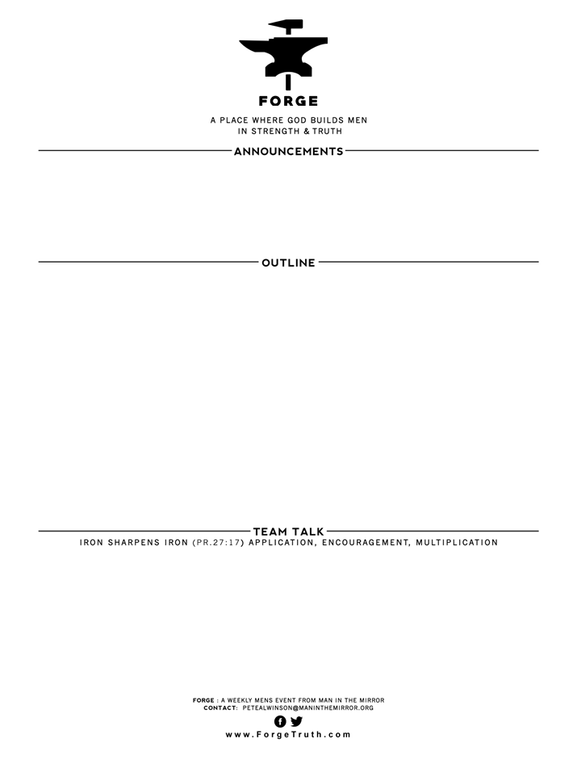

**THE WAY OF GREAT MEN- TALK 8--A NON-CONDEMING HEART**

May 23, 2017 I John 3:18-24

1. FEELING FORGIVEN **AND** CONDEMNED: V18-20
2. LIVING UNCONDEMNED: v 21-24
3. What situation happened to you since the last FORGE when we talked about love that called you out to be more loving and make some of the lesser sacrifices John talked about in I John 3:17? Tell a couple of stories
4. Talk around the table about how John taught us today to deal with heart condemnation when it happens.
5. Take time to for prayer requests around the table starting at around 6:45 and pray for each other, including that we as men will grow in love!

**WELCOME TO FORGE!**

* **Want our Eblasts? Sign up:** [**www.ForgeTruth.com**](http://www.ForgeTruth.com)
* **Want to view a message you missed:** [**www.ForgeTruth.com**](http://www.ForgeTruth.com)
* **Today: First Timers; Coffee & Lights ($3-5); let’s go!**