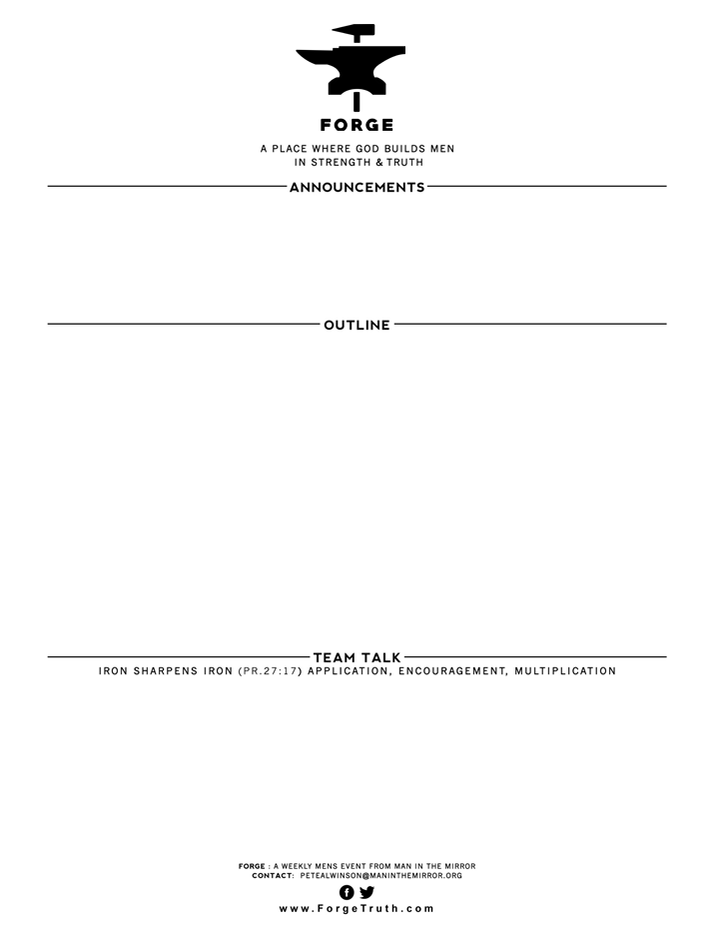

THE WAY OF GREAT MEN- Talk 7 LOVING YOUR WAY TO GREATNESS I John 3:10-19

Intro: 10-11

1. CAIN: (The Man Not To Be) THE WAY OF HATE IS THE WAY OF DISASTER- V12
2. JESUS: (The Man To Follow) THE WAY OF LOVE IS THE WAY OF GREATNESS-V14
3. As you look at Cain’s life do you clearly see the often typical sequence of: jealousy, hate & murder that operates in the world around us? Does the Apostle John go too far in saying that people who are “haters” are “murderers”?(v15). How have you as a Christ-follower dealt with your strong negative feelings about others, especially Christians? If you feel comfortable, share a story about someone you struggled not to hate!
4. What have you learned about loving people, especially Christians, in the real world of their sins and weaknesses?

**WELCOME TO FORGE!**

* **Want our Eblasts? Sign up:** [**www.ForgeTruth.com**](http://www.ForgeTruth.com)
* **Want to view a message you missed:** [**www.ForgeTruth.com**](http://www.ForgeTruth.com)
* **Today: First Timers; Coffee & Lights ($3-5); let’s go!**