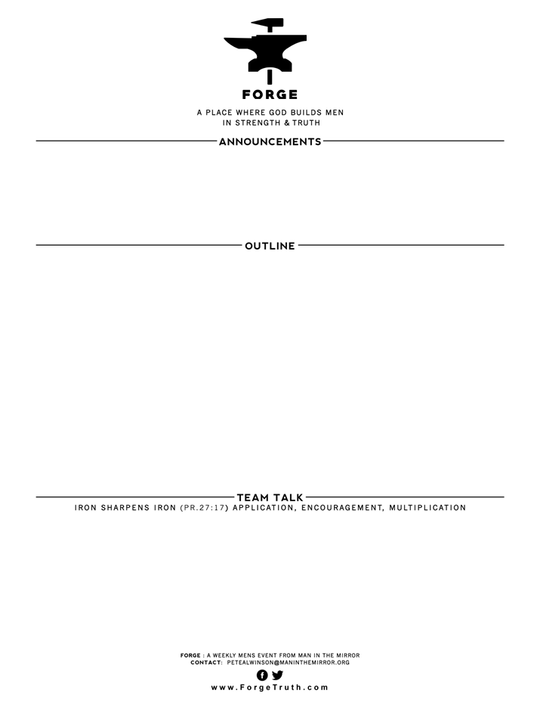

THE WAY OF GREAT MEN SERIES- Talk 5 THE TRUTH TEST- I John 2:18-27

1. ANTICHRISTS & CHRISTIANS: V18-21
2. LIARS & TRUTHERS: V 22-23
3. TRUTH PROMOTERS & PROTECTORS: V24-27
4. From v18-21- how did we define “antichrist”? What did you learn about their staying power in the church? Why do they leave the active life of the church? Why is it important that Christian men understand that anti-christs can be in the church?
5. In v 22-23 we talked about the central point of most heresies and false teachings in the church. What is that central issue that anti-christs mislead others? What does the word “Christology” mean? 3. Are there really people trying to deceive Christians away from the truth? V24-27. What does John teach that can keep us from being deceived?

**WELCOME TO FORGE!**

* **Want our Eblasts? Sign up:** [**www.ForgeTruth.com**](http://www.ForgeTruth.com)
* **Want to view a message you missed:** [**www.ForgeTruth.com**](http://www.ForgeTruth.com)
* **Today: First Timers; Coffee & Lights ($3-5); let’s go!**