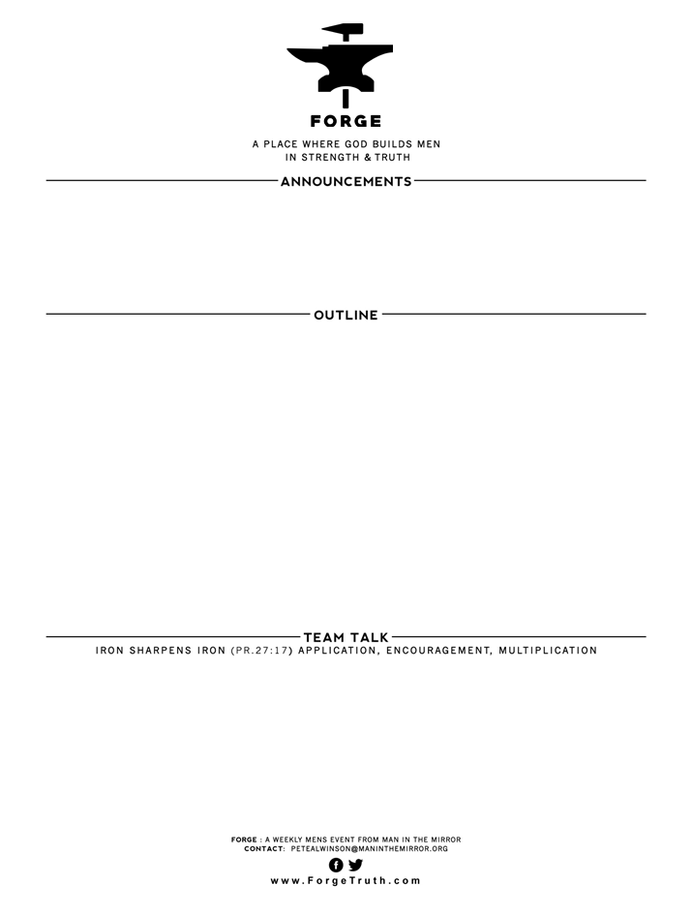

**THE WAY OF GREAT MEN SERIES- Talk 4**

**KNOWING THAT YOU KNOW THAT YOU KNOW GOD-TESTS FOR ASSURANCE -** Part 2

**I John 2: 7-17 The Social Test of Assurance:**

1. **Love Taught: v7-11**
2. **Love Modeled: v12-14**
3. **Love Clarified: v15-17**
4. Under point I. above what did John mean by love being a “new commandment”?
5. How do we men get to the point where we hate? What brings out hate in you? Why is it good for a Christian man to recognize it when hate begins to develop in our hearts? How have you come to deal with your hates?
6. Under point II. Above John models love to the Christians …how does he do that? How can you practically love those around you in the same way?
7. Point III---What is an important take away in these verses for you today?

**WELCOME TO FORGE!**

* **Want our Eblasts? Sign up:** [**www.ForgeTruth.com**](http://www.ForgeTruth.com)
* **Want to view a message you missed:** [**www.ForgeTruth.com**](http://www.ForgeTruth.com)
* **Today: First Timers; Coffee & Lights ($3-5); let’s go!**