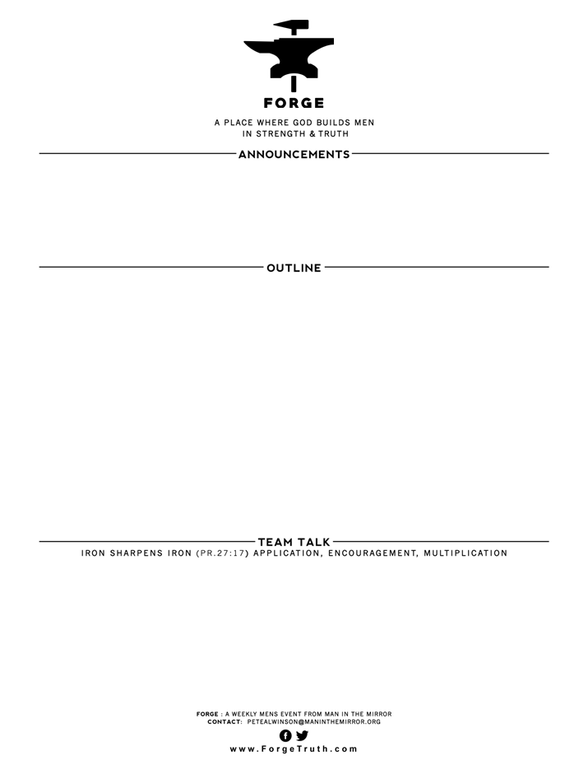

**I JOHN: THE WAY OF GREAT MEN-Talk 2- A MAN’S WALK WITH GOD...I John 1:5-2:2**

1. **THE GOD OF LIGHT- V5**
2. **THE WALK IN LIGHT-V6-2:2---3 False Scenarios; 3 True Scenarios**
3. Discuss John’s macro truth about God being LIGHT. Review briefly what that means and how that can expand a man’s view of God. Why do we tend to have too small a view of God? Can we have too big a view of God? How does a man grow into a “greater” man by having a big view of God?
4. It is clear from John’s teaching that a Christian man cannot ever justify consistently sinning in rebellion toward God and say that he is in fellowship with God. How should we get sin into perspective as disciples; what are the extremes to avoid?

**WELCOME TO FORGE!**

* **Want our Eblasts? Sign up:** [**www.ForgeTruth.com**](http://www.ForgeTruth.com)
* **Want to view a message you missed:** [**www.ForgeTruth.com**](http://www.ForgeTruth.com)
* **Today: First Timers; Coffee & Lights ($3-5); let’s go!**