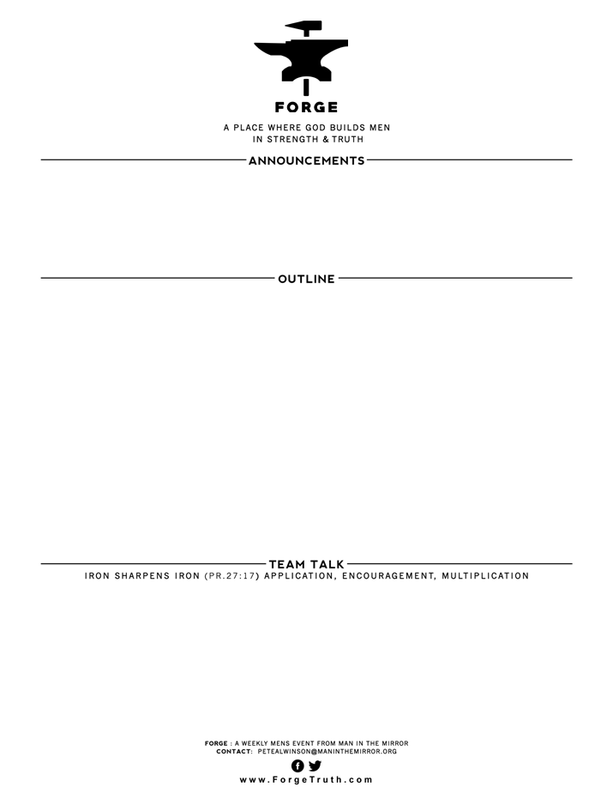

**5 MARKS OF GREATNESS I John 5:13-21 Talk 12**

1. **A SETTLED CONFIDENCE AS A SON: V13**
2. **A SETTLED CONFIDENCE IN ANSWERED PRAYER: V14-17**
3. **A SETTLED CONFIDENCE OF PROGRESSIVE GROWTH: V 18-19**
4. **A SETTLED CONFIDENCE IN JESUS CHRIST AS TRUTH:V20**
5. **A SETTLED CONFIDENCE IN THE SUPREMACY & LOYALTY TO GOD:V21**
6. WHICH of the 5 marks of greatness stands out to you as particularly important at this point in your life? Why?
7. Do you intentionally think of becoming a great man as God defines greatness as we have been talking about in this series? Why or why not? Have you been persuaded to seek to become a great man as God defines greatness? Why or why not?
8. How do “Iron Sharpens Iron” friendships with other growing Christian men support your progress in growth? How does the grace of God in Christ energize our growth as men?

**WELCOME TO FORGE!**

* **Want our Eblasts? Sign up:** [**www.ForgeTruth.com**](http://www.ForgeTruth.com)
* **Want to view a message you missed:** [**www.ForgeTruth.com**](http://www.ForgeTruth.com)
* **Today: First Timers; Coffee & Lights ($3-5); let’s go!**