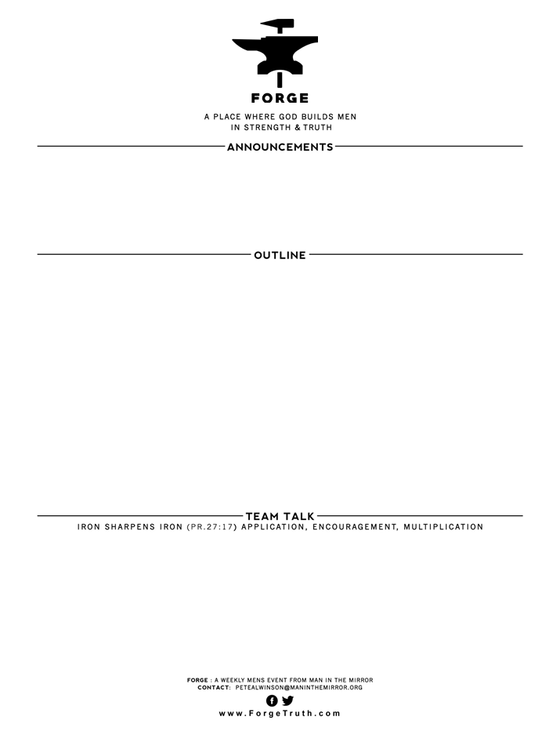

**THE WAY OF GREAT MEN- I JOHN-TALK 11 CONFIDENCE & WINNING June 13, 2017…………………….………I John 5:1-12**

1. **HOW DISCIPLES GAIN CONFIDENCE & WIN: v1-5**
2. **HOW DISCIPLES BELIEVE AND WIN: v6-12**
3. Where have you found confidence in the past? Was that source of confidence sound? Did it produce the desired effect for you? Talk around the table about this…adding in where you wanted to WIN!
4. In the past did you ever think that God’s commands were burdensome? (v3) Do you still think that way? Have you come to the point where God’s commands are seen as valuable and NOT a burden? Give an illustration.
5. What did you learn about how we grow to have faith in Christ? (v6-12)

**WELCOME TO FORGE! Brief TABLE LEADER MEETING AFTERWARDS TODAY**

* **Want our Eblasts? Sign up:** [**www.ForgeTruth.com**](http://www.ForgeTruth.com)
* **Want to view a message you missed:** [**www.ForgeTruth.com**](http://www.ForgeTruth.com)
* **Today: First Timers; Coffee & Lights ($3-5); let’s go!**